Here’s one method for building a Scraps prop. There are others which may be better/easier, but this is at least one way to get it done.

- Choose a prop shape. I selected Stan Chilton’s UFO Ministick prop because it looks great, and it seemed like it would flare nicely: https://indoornewsandviews.com/2019/11/06/stan-chiltons-cat-ii-record-mini-stick/

- The prop diameter on the printed plan is 2-3/16”, so I reprinted it at 114% to get it to 2.5” diameter

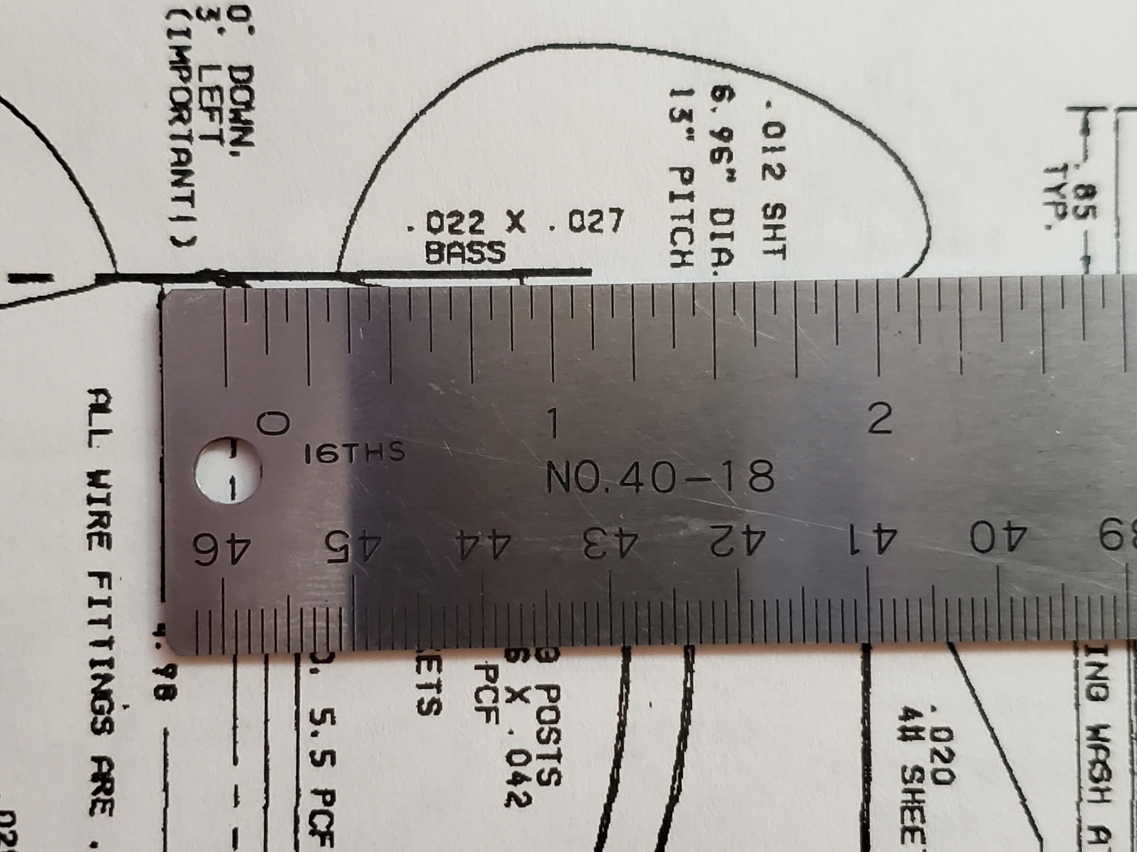

- Cut the prop shape out to use as a template

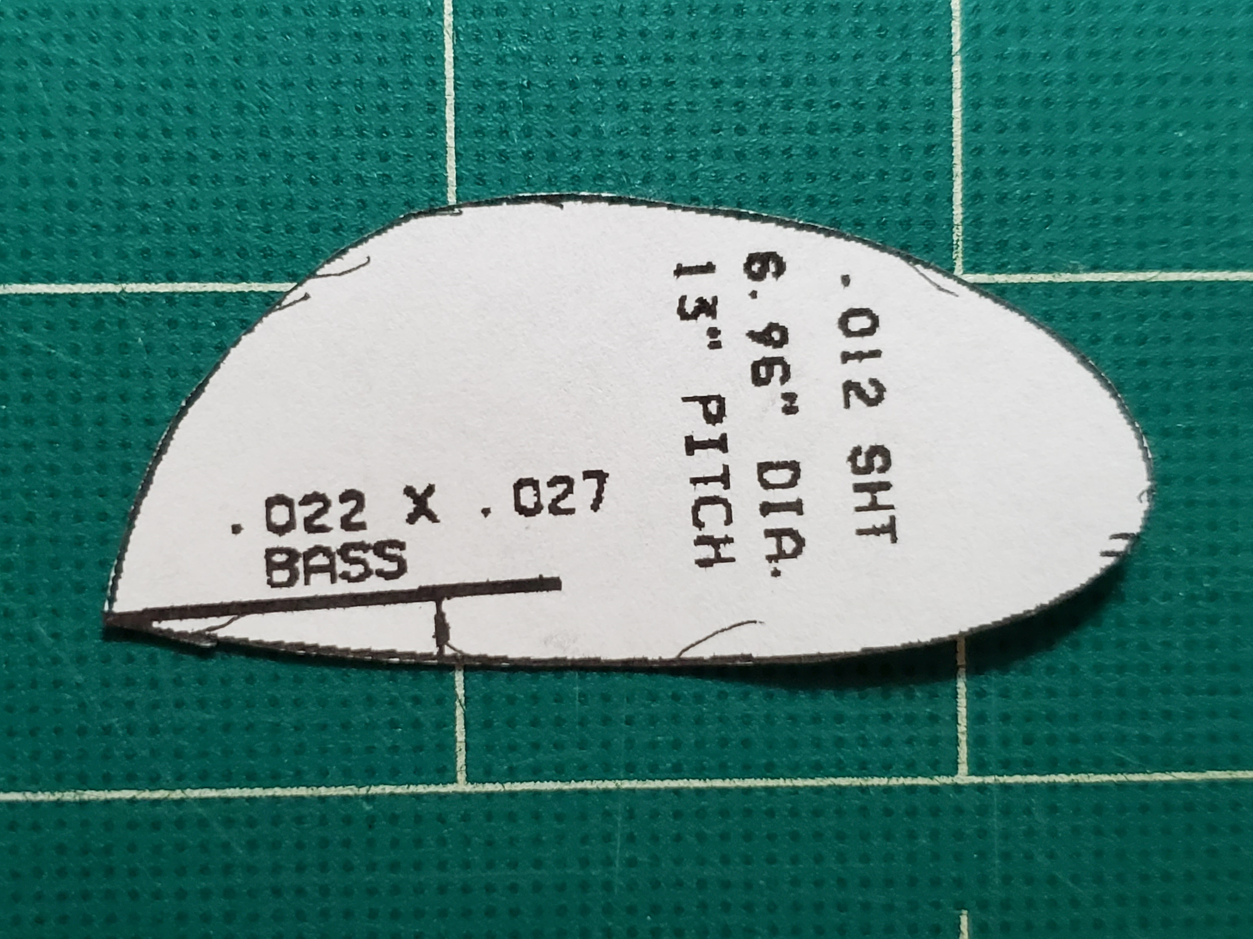

- Mark the spar location on both ends of the template, even if the spar won’t go all the way to the tip. These marks will be transferred to the prop blade and used for lining it up during forming and when attaching it to the spar

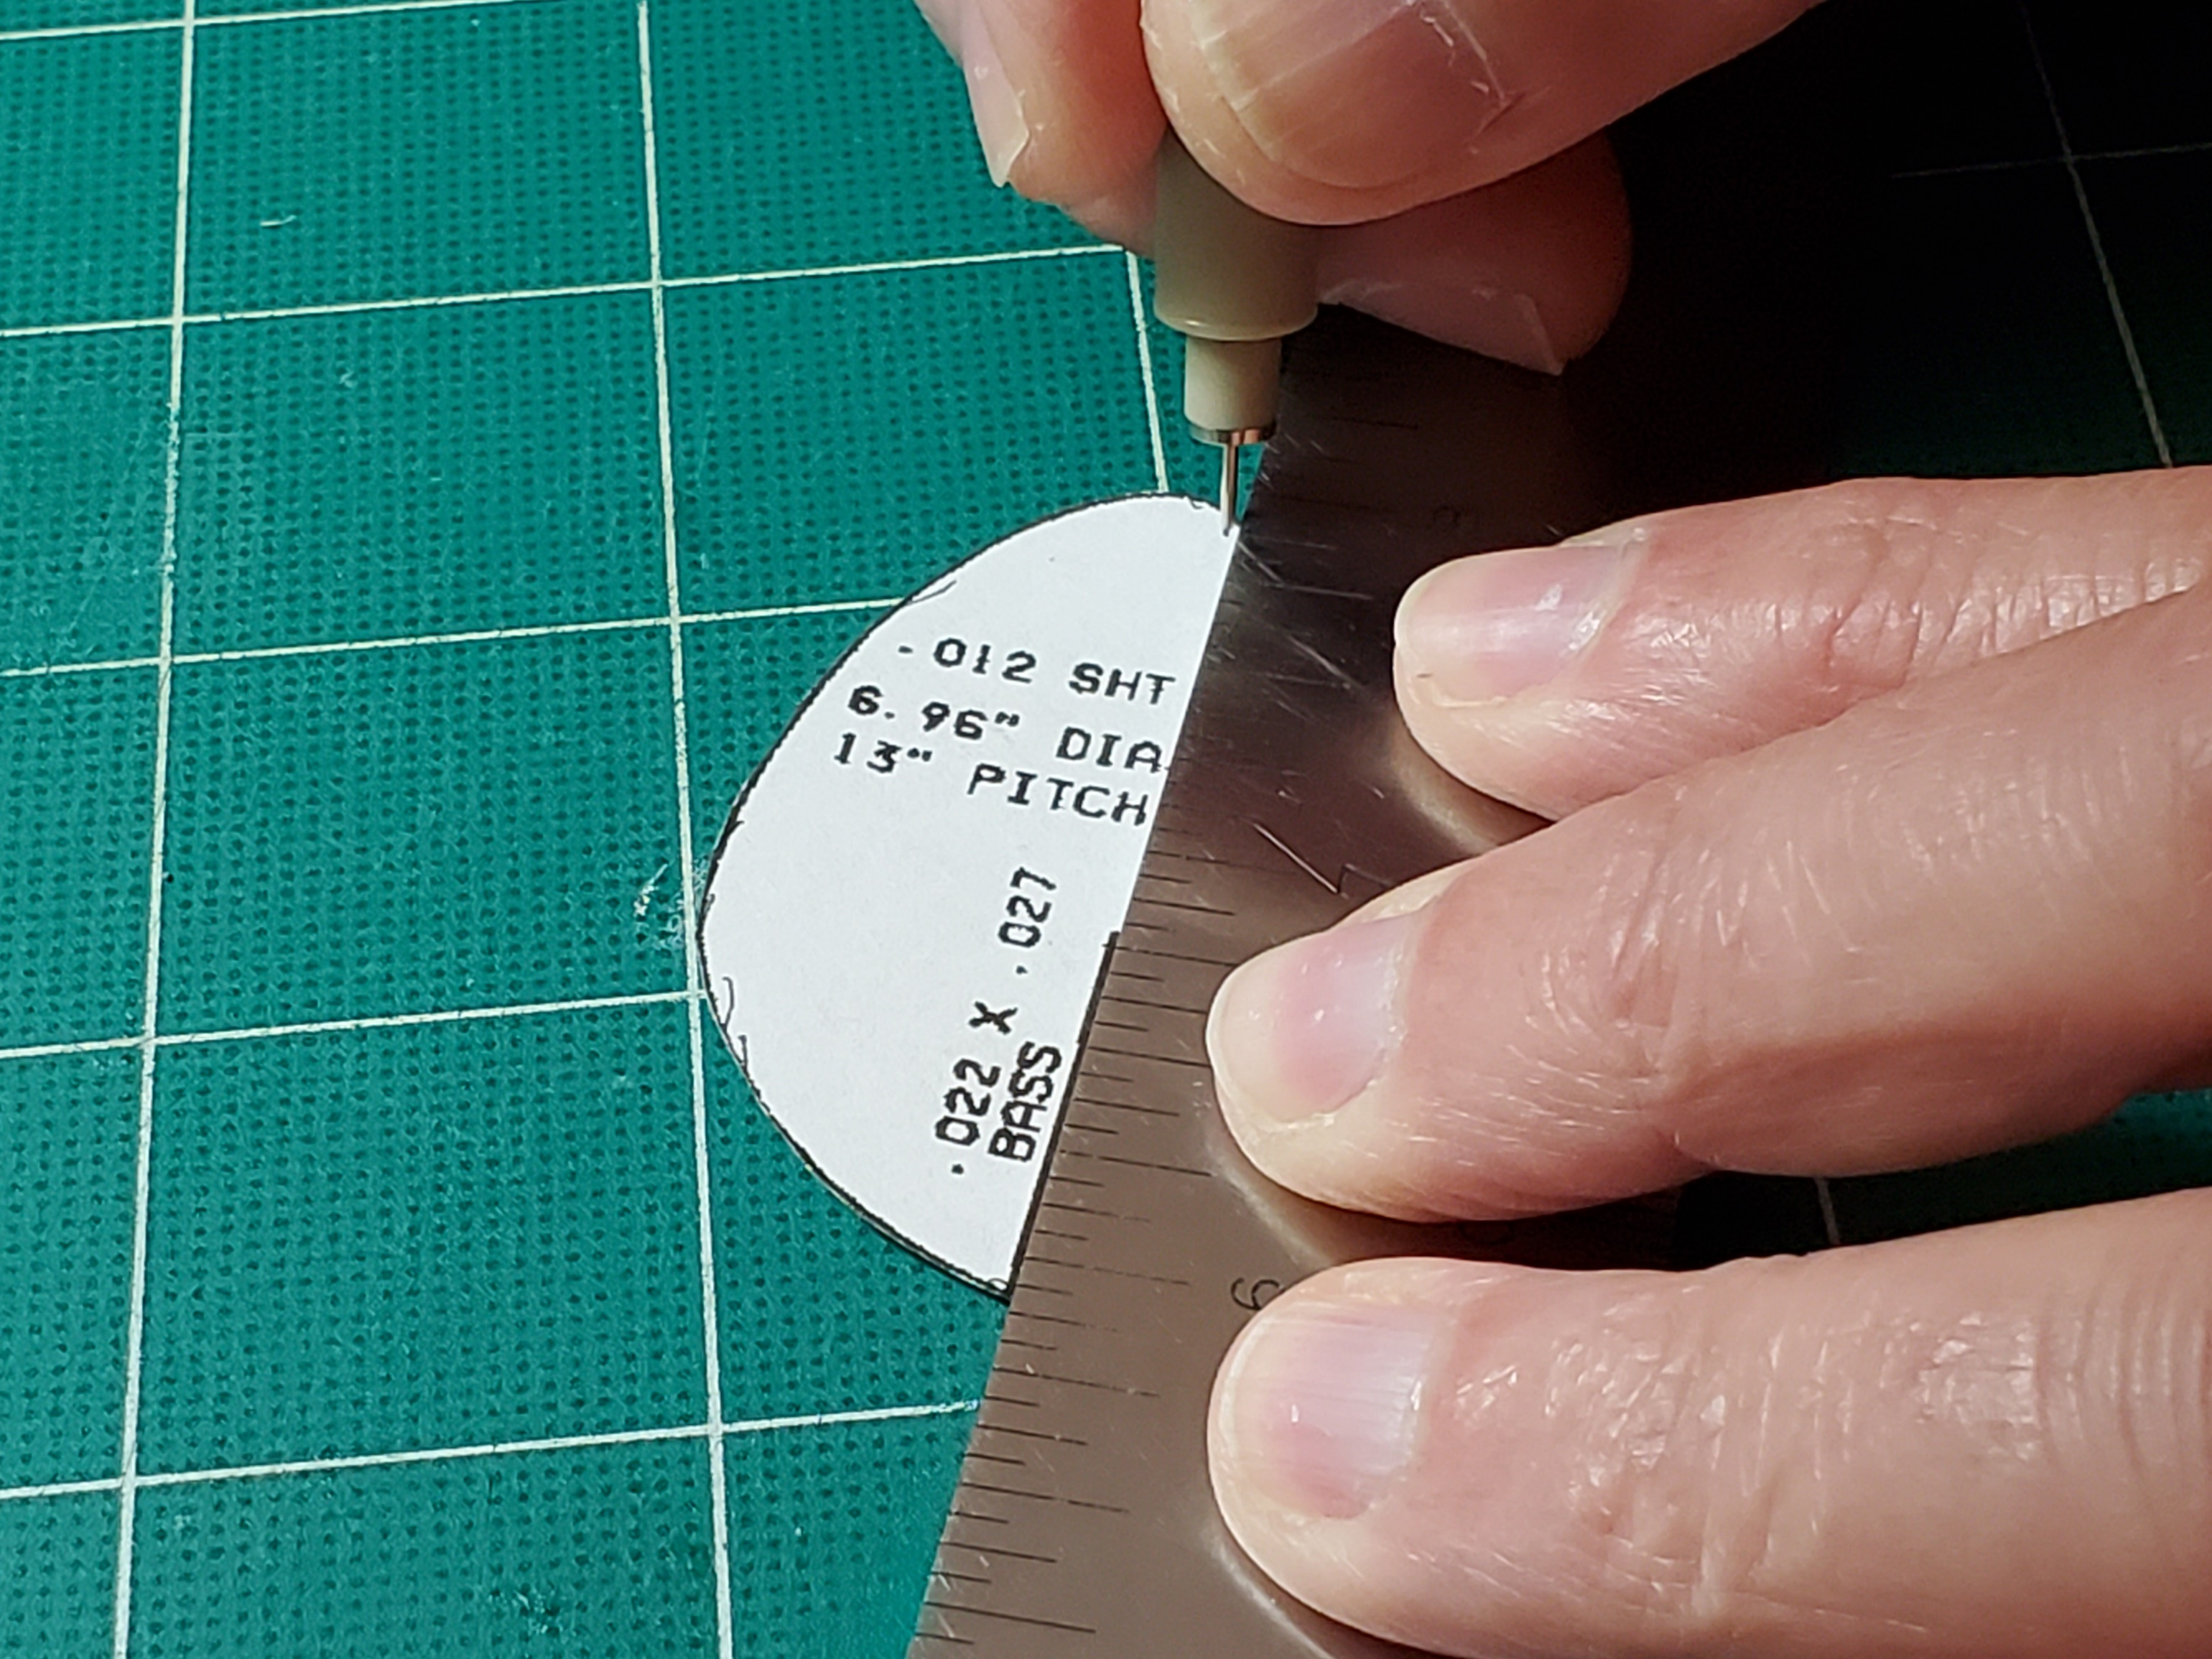

- Select the wood for your prop blade. I had some .013” scraps left over from F1D motorsticks. If you don’t, you can sand some wood down to size by gluing down some sandpaper with appropriate diameter wire on either side, and carefully sanding with a flat sanding block. Be very careful as the wood gets thin so that you don’t crumple it

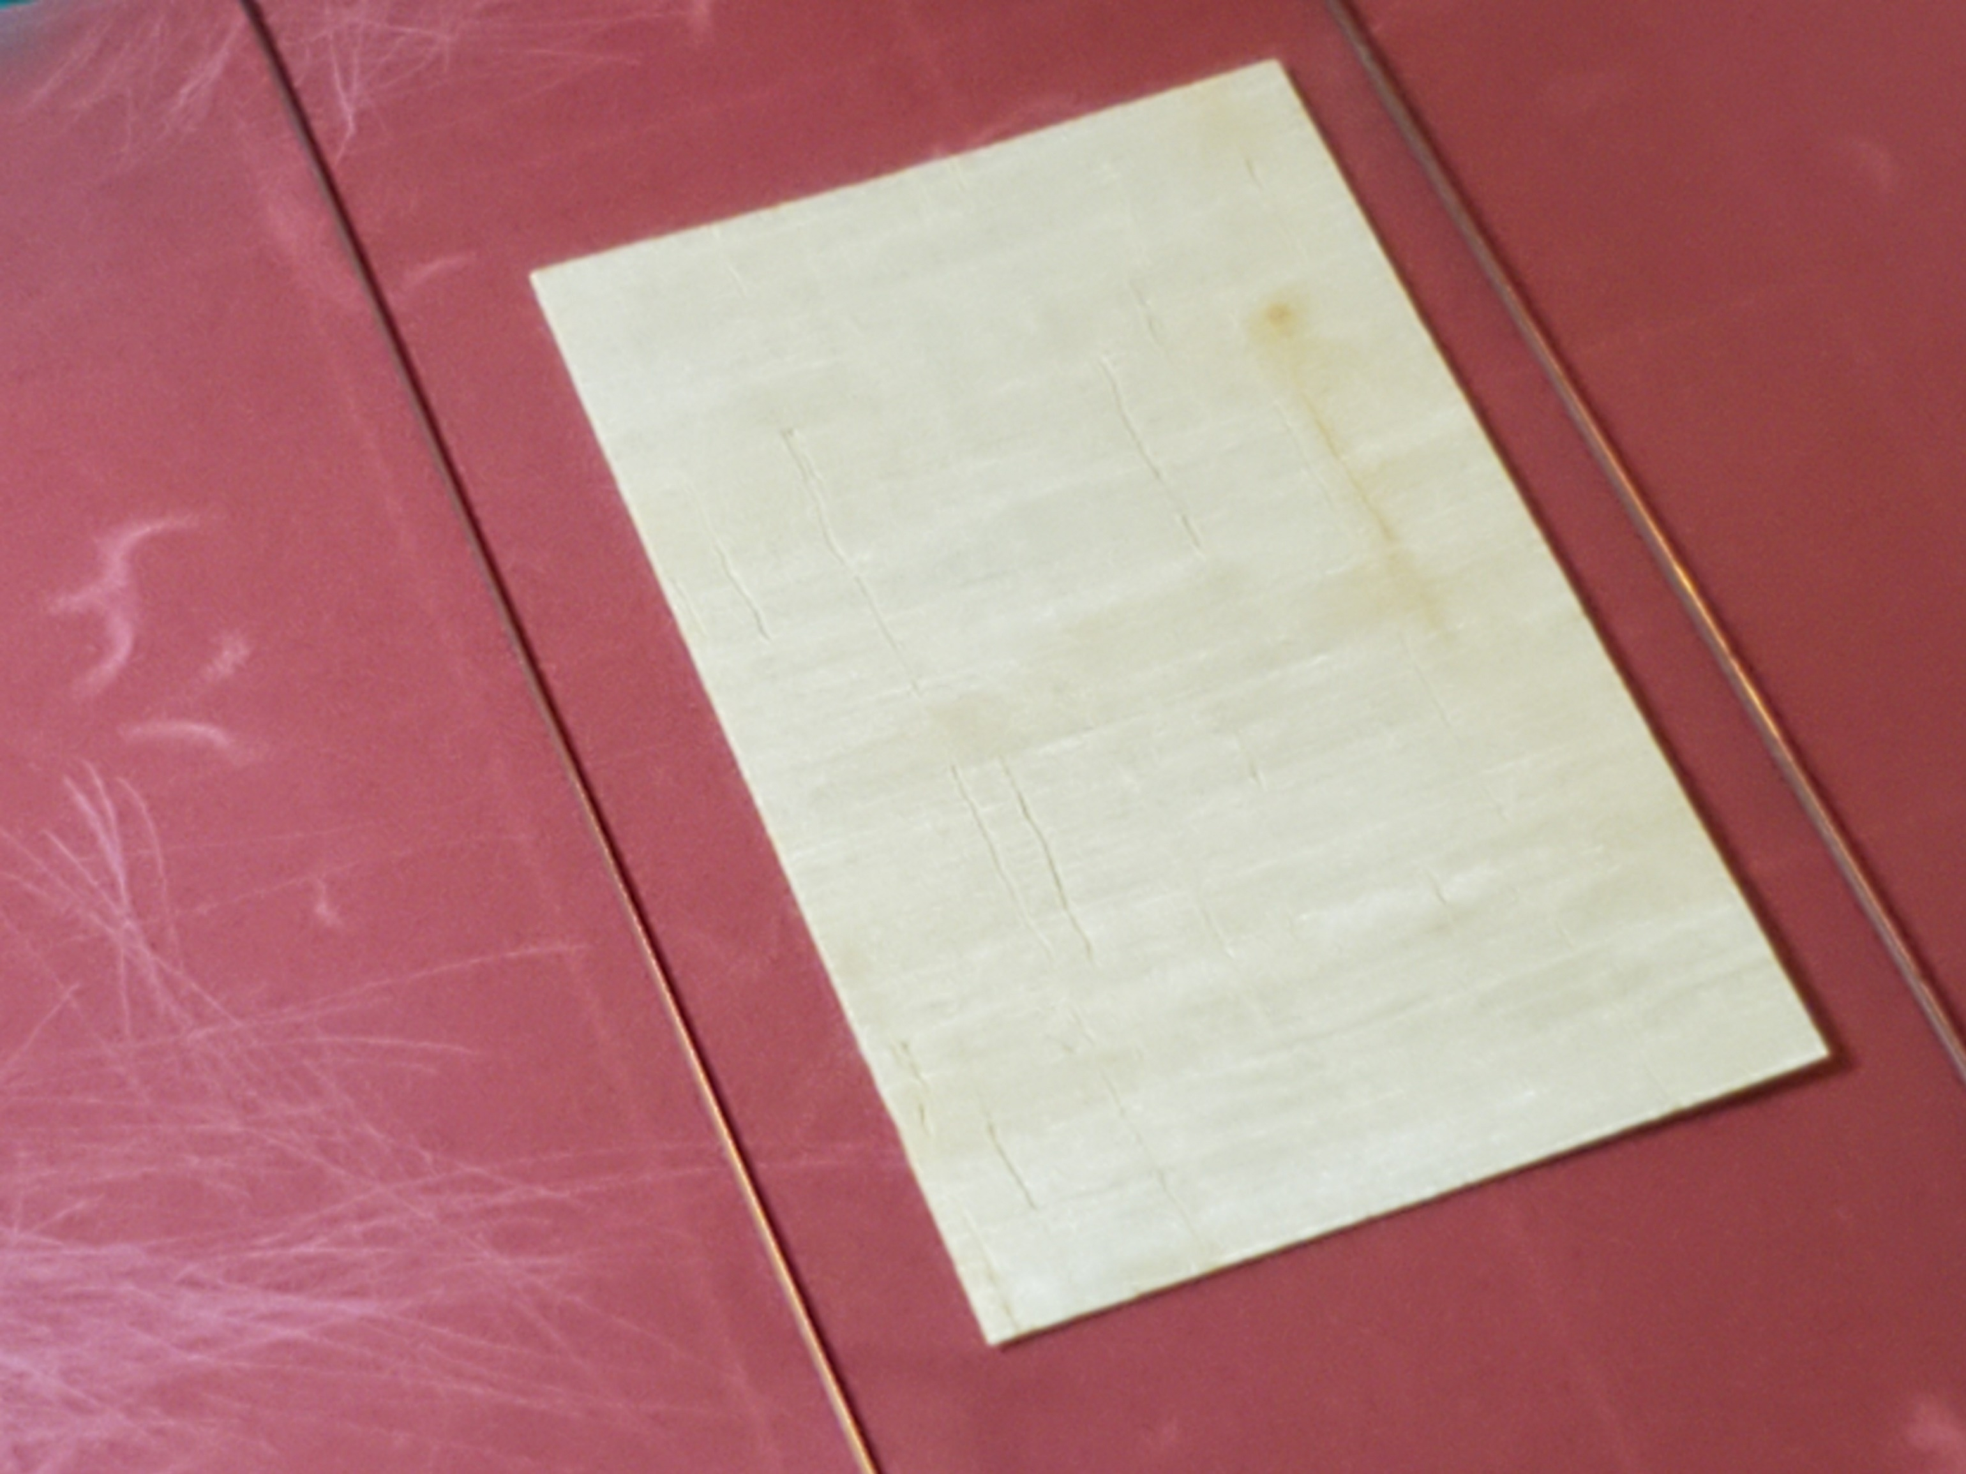

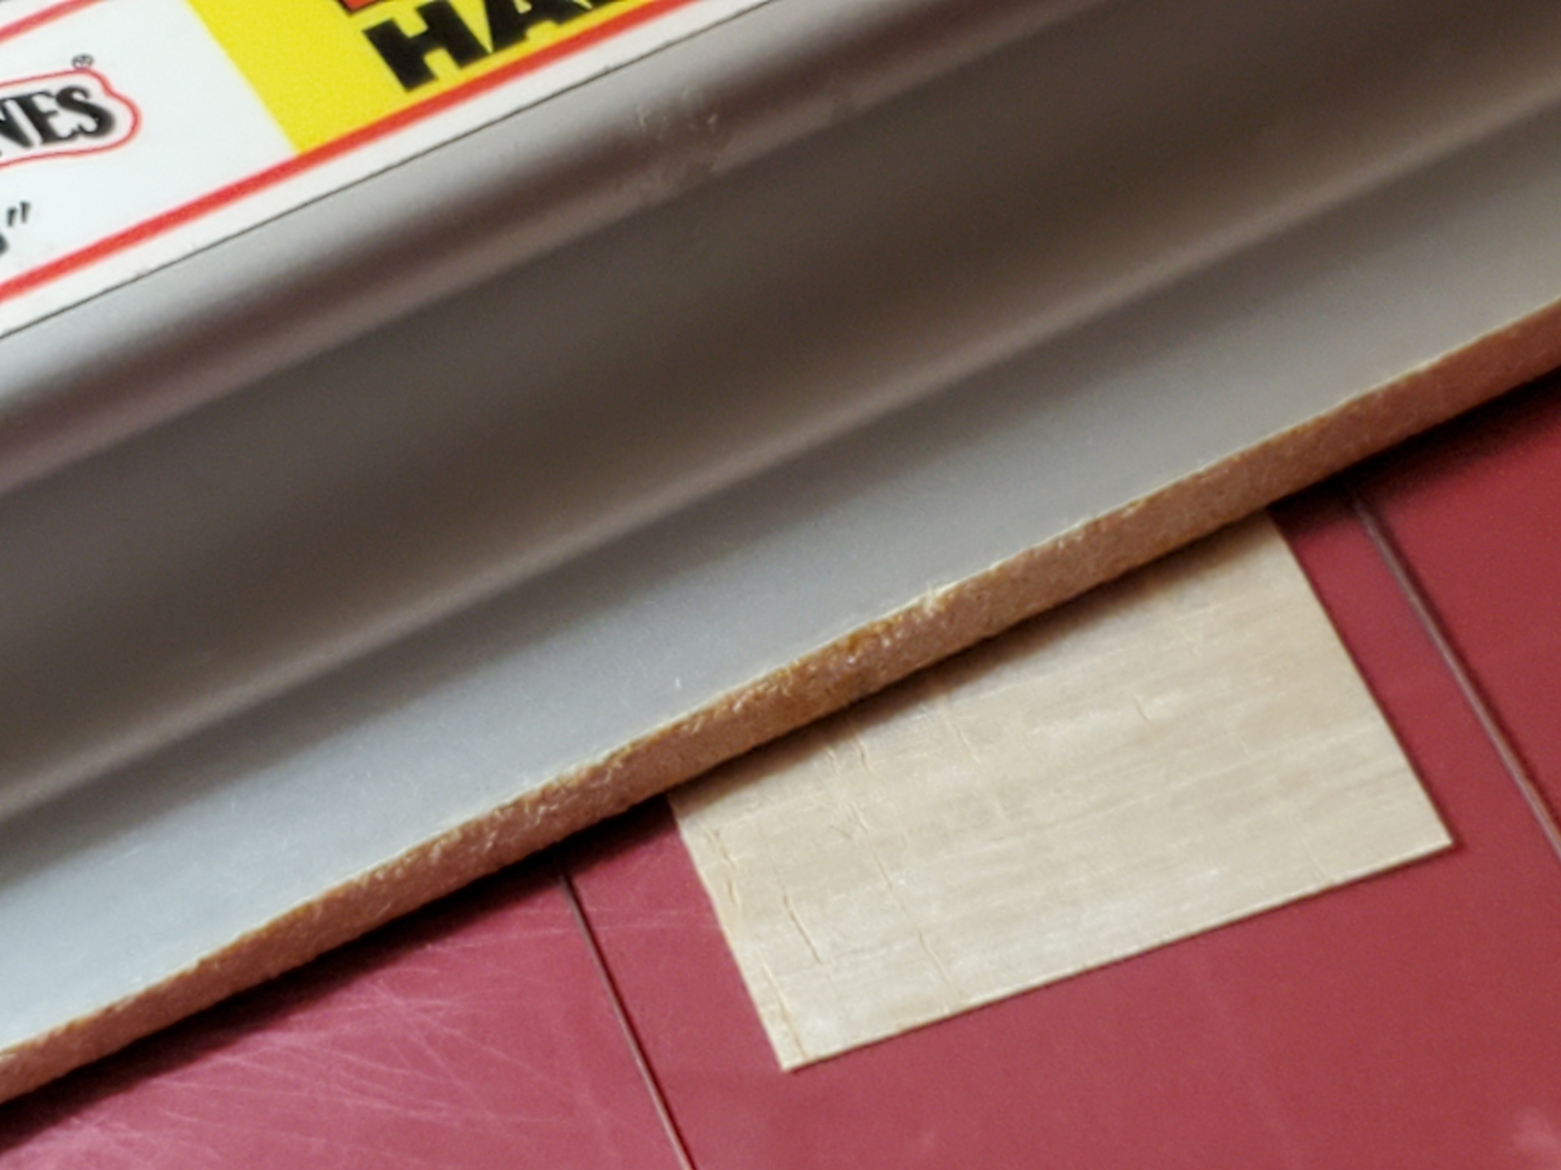

- My 2-1/8” x 1-1/4” blank weighs .035gm

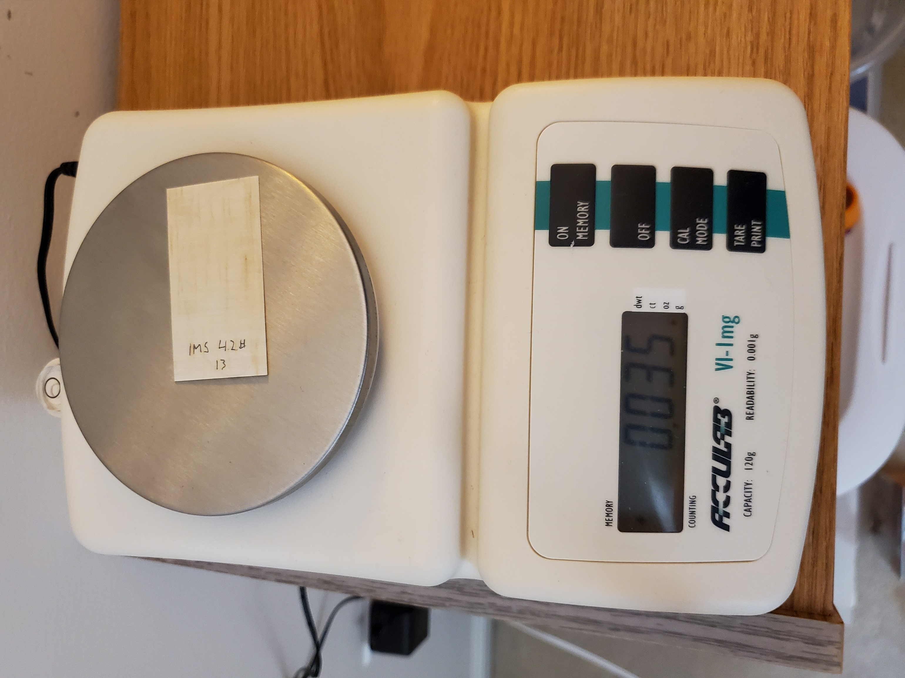

- Trace the outline onto the prop wood

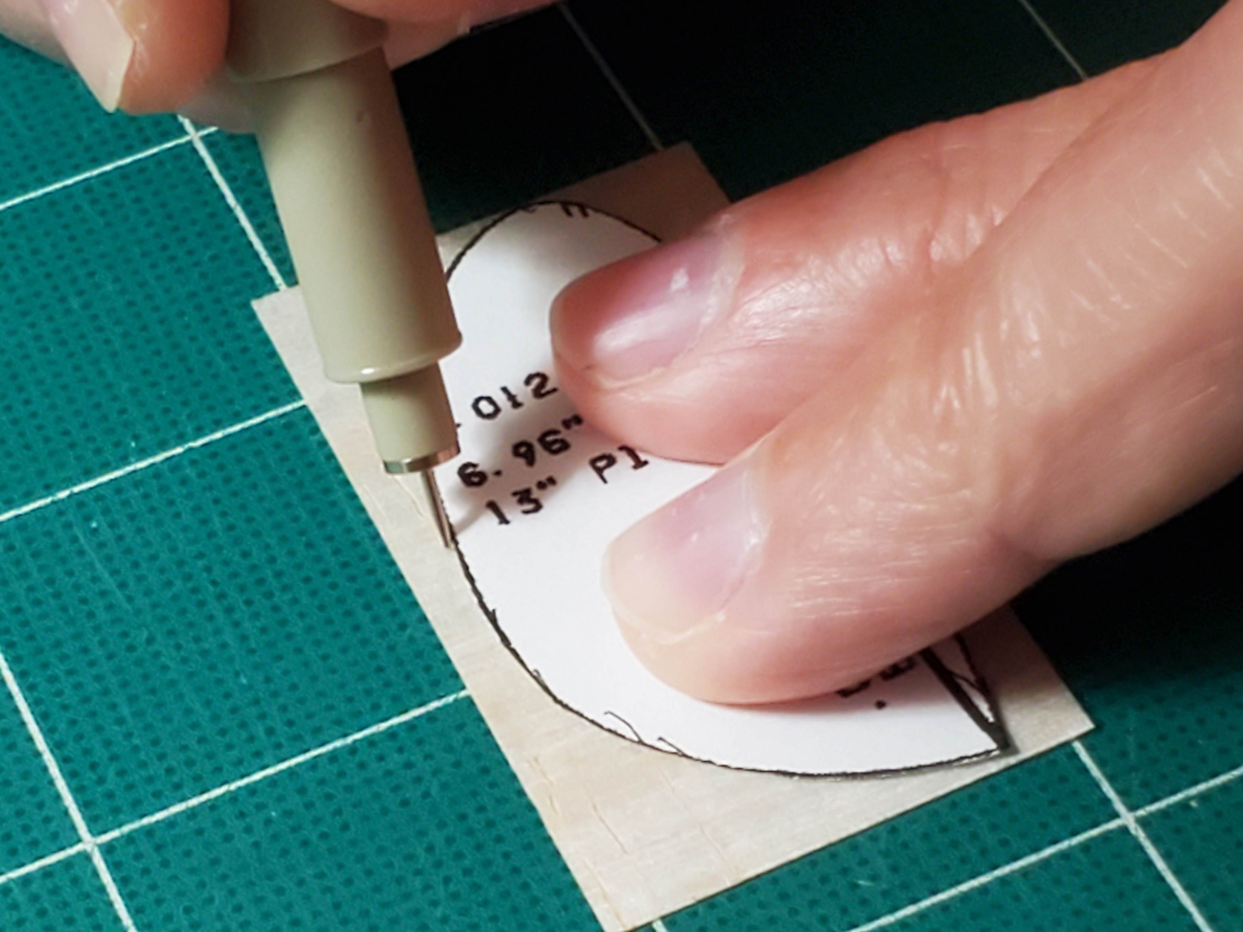

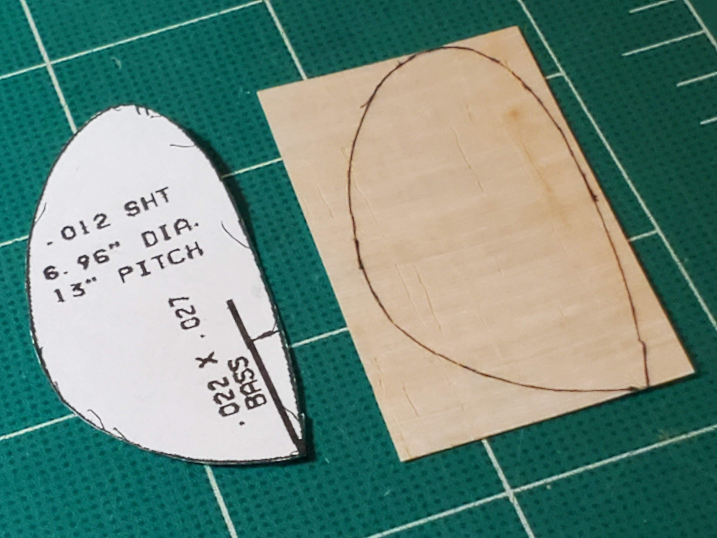

- …and cut it out. Scissors work nicely for this

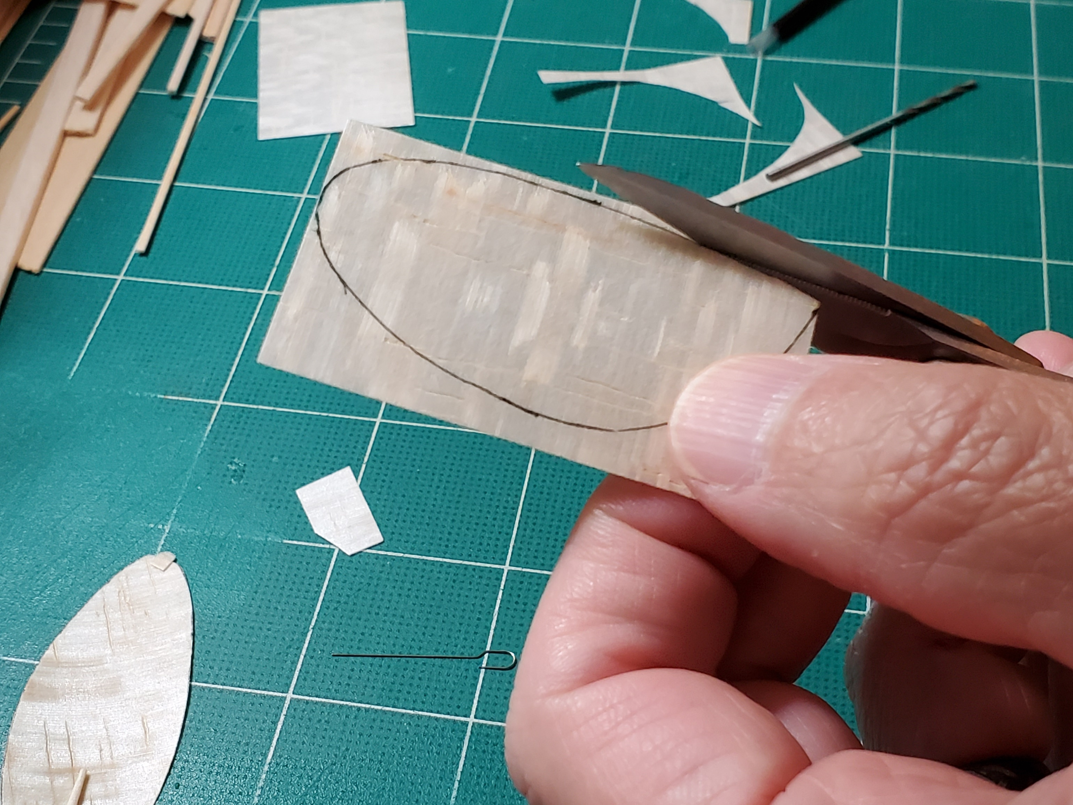

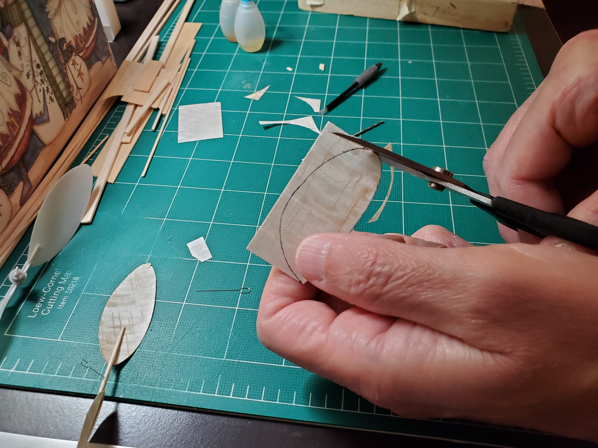

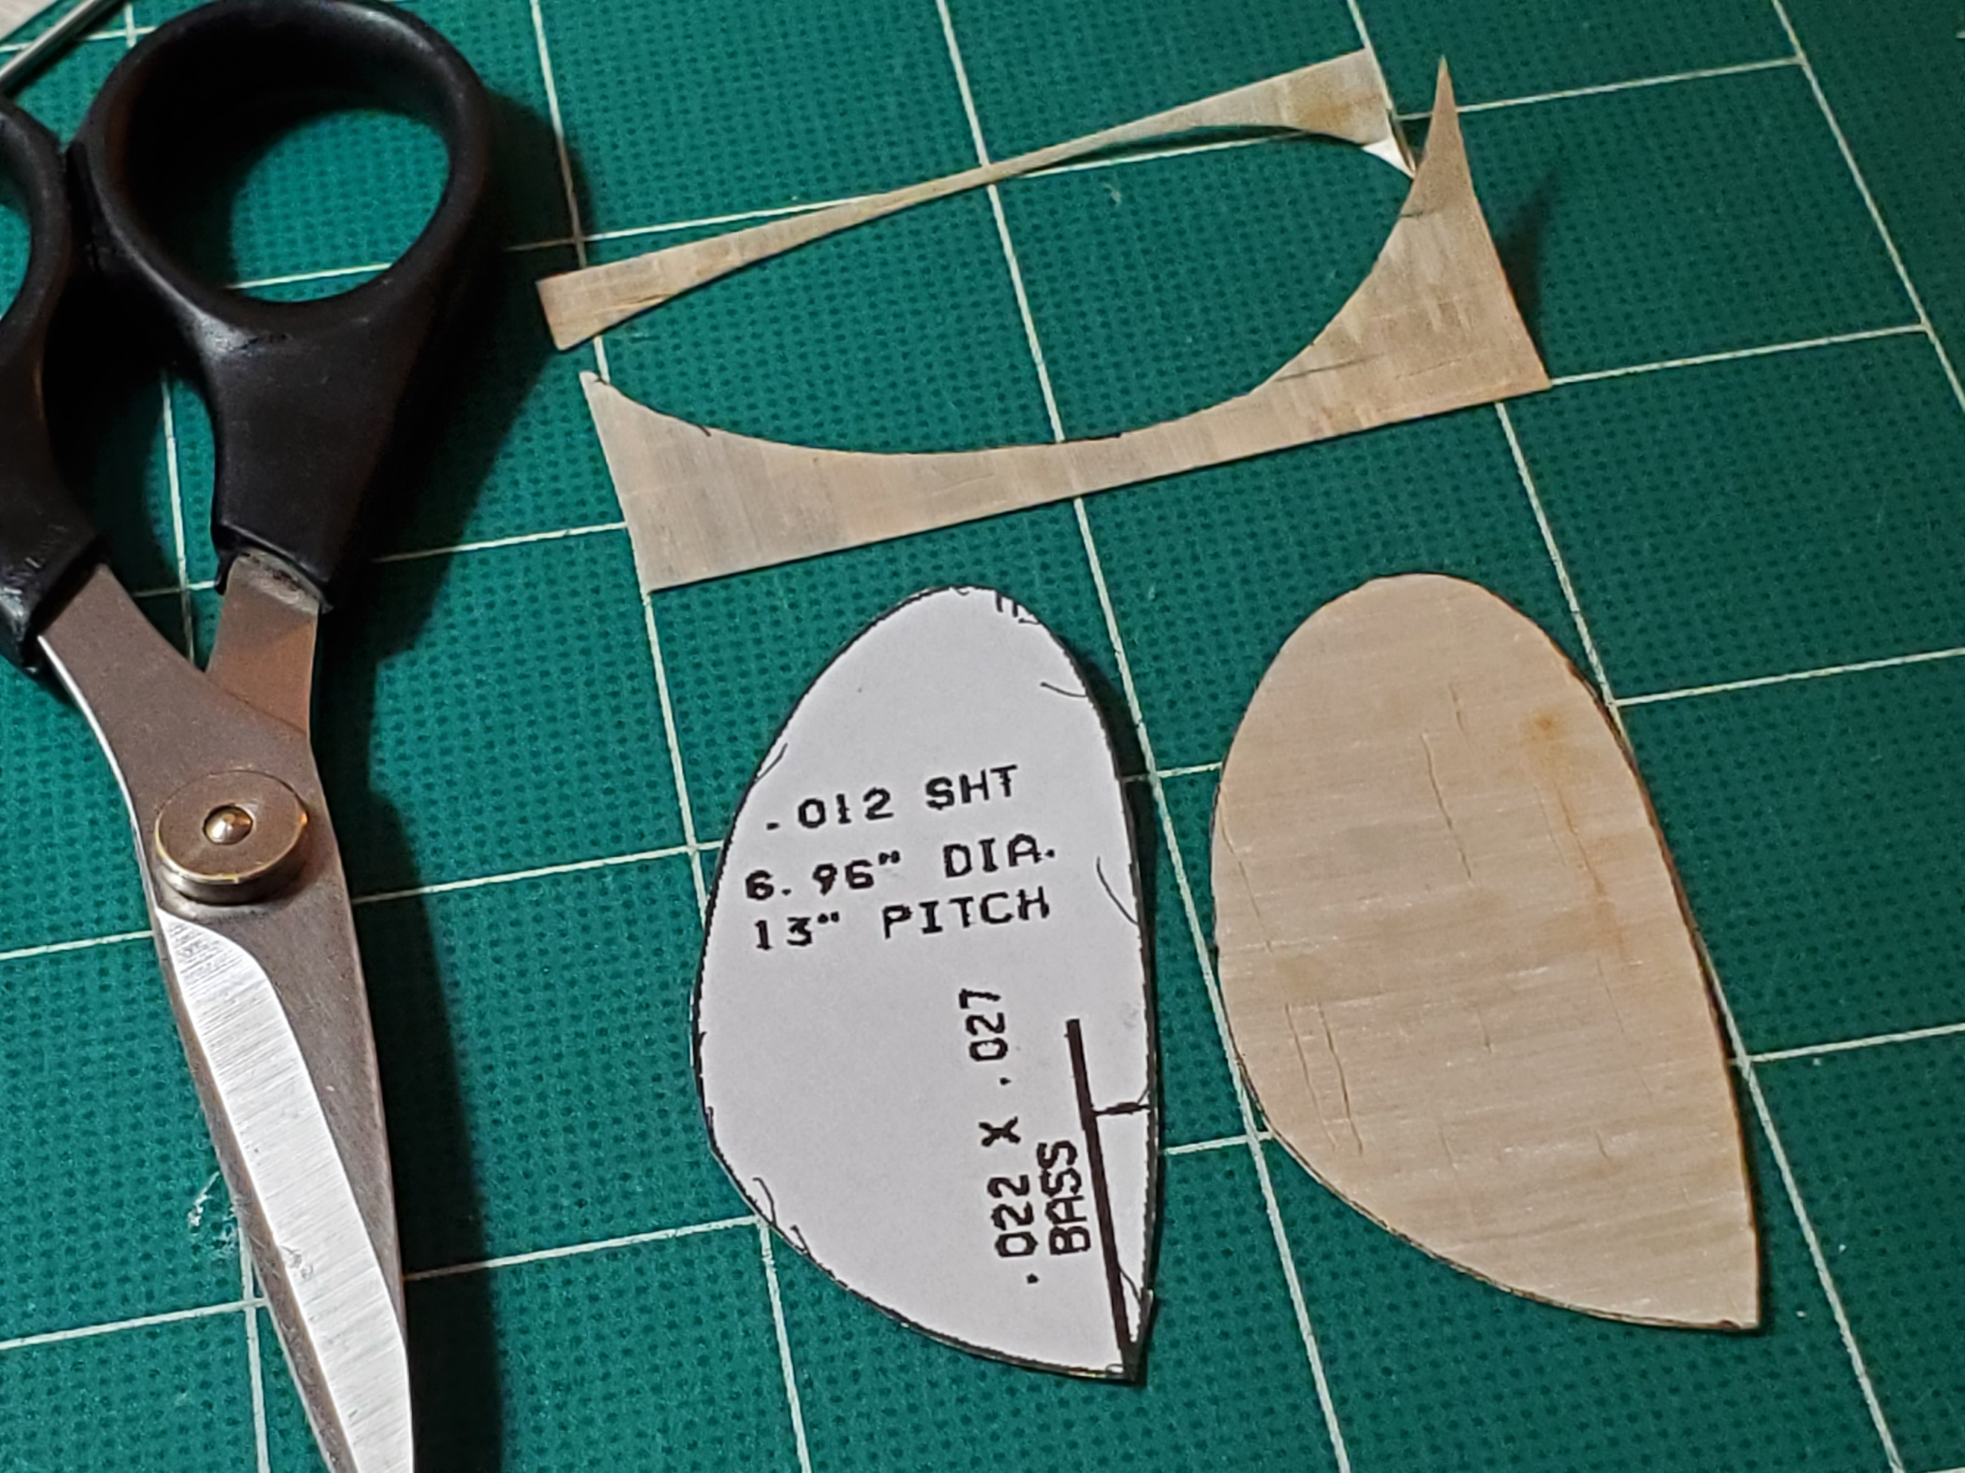

- Use the spar mark on the template to mark the spar location on the prop blade

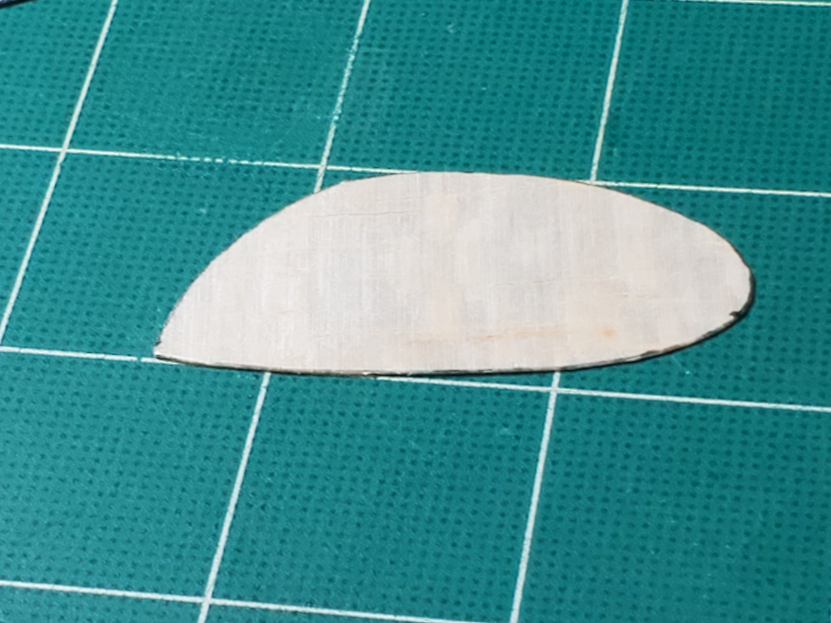

- My prop blade weighs .022gm

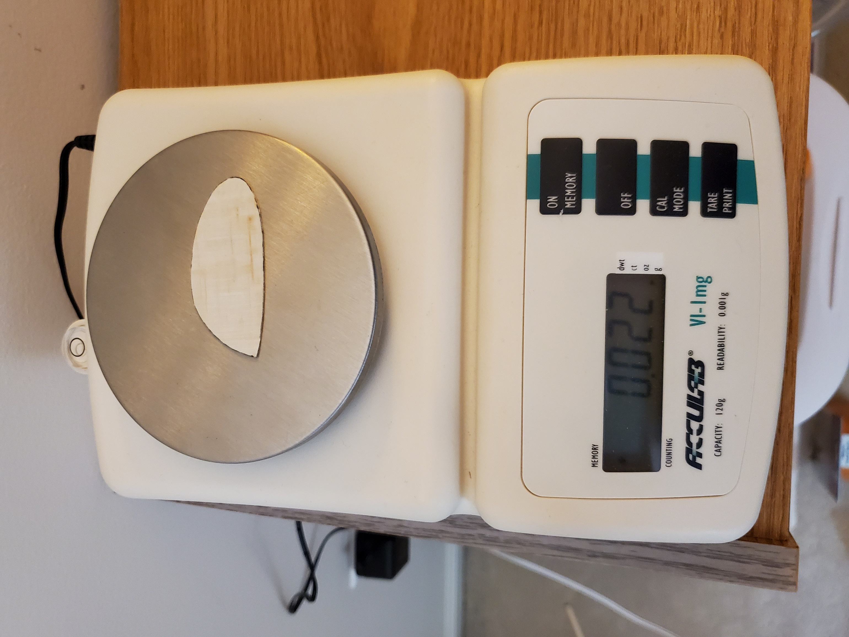

- I have a cambered prop block that I carved for EZB many years ago. On the back side I carved another face for Ministick props. Ron Williams’ book, Building and Flying Indoor Model Airplanes, has a great section on carving prop blocks. I highly recommend it – it’s what got me into F1D https://books.google.com/books?id=cYlBTKmuX90C&pg=PA74&lpg=PA74&dq=carved+%22prop+block%22&source=bl&ots=brOrR1dxRU&sig=ACfU3U2pgeYUQFfCAxrwZL5XlZO7d7F42Q&hl=en&sa=X&ved=2ahUKEwirubmY7evoAhUDOs0KHYTTB-I4ChDoATADegQIDBAo#v=onepage&q=carved%20%22prop%20block%22&f=false

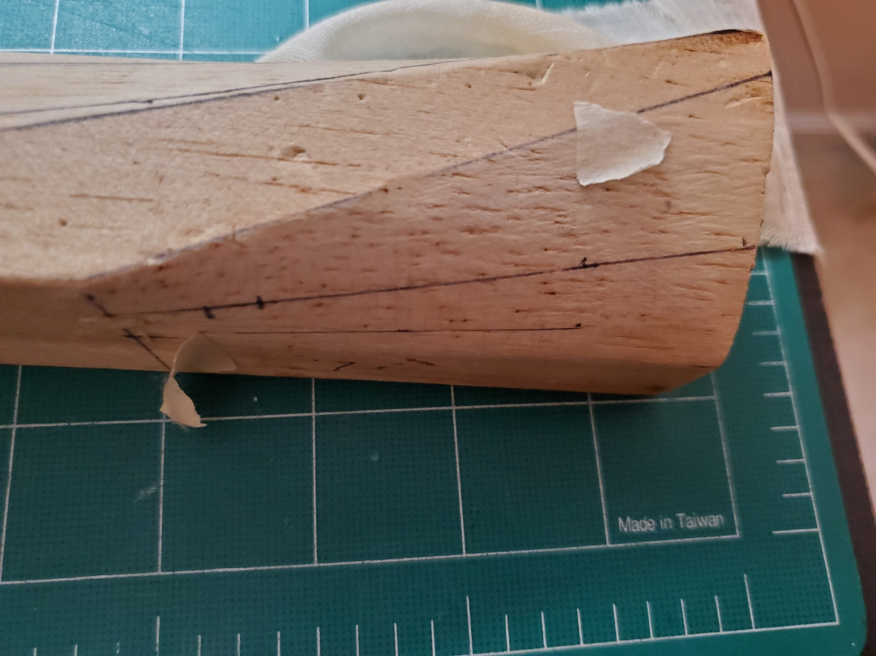

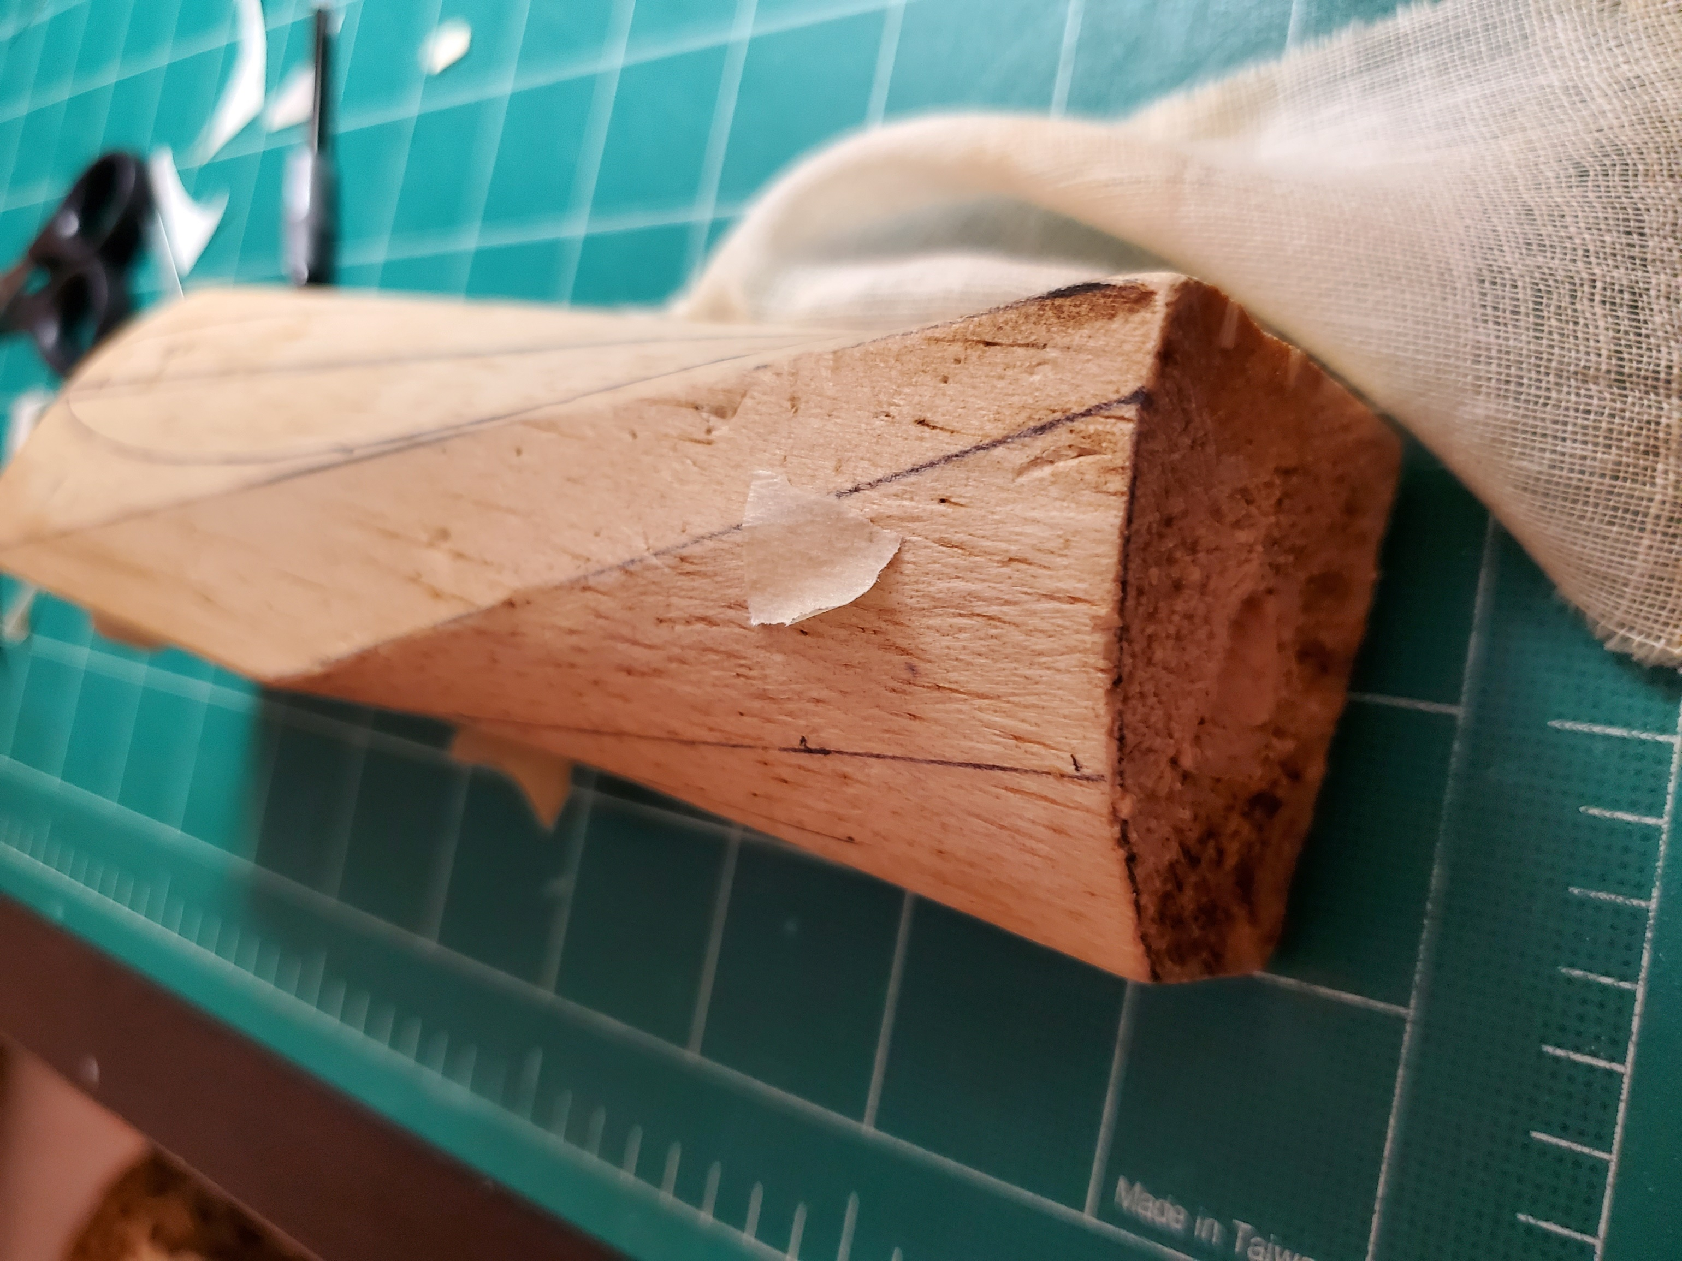

- You can also form the blade on a can/bottle/tube. My calculations suggest at 16 degrees on a 1” tube is about right. Notice that the blade shape is almost identical when I hold it at 16 degrees on this can. You can see the 16 degree line I drew on the can peeking out by the tip of the prop blade

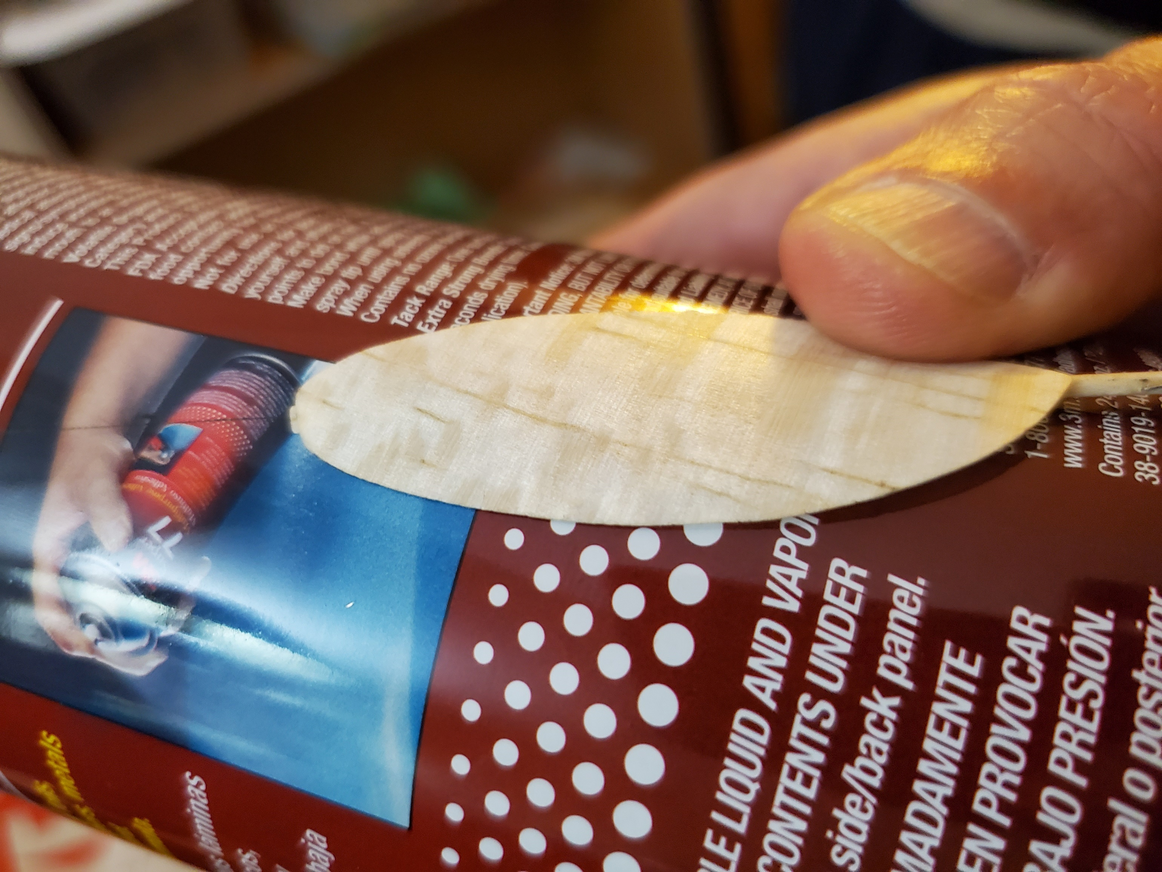

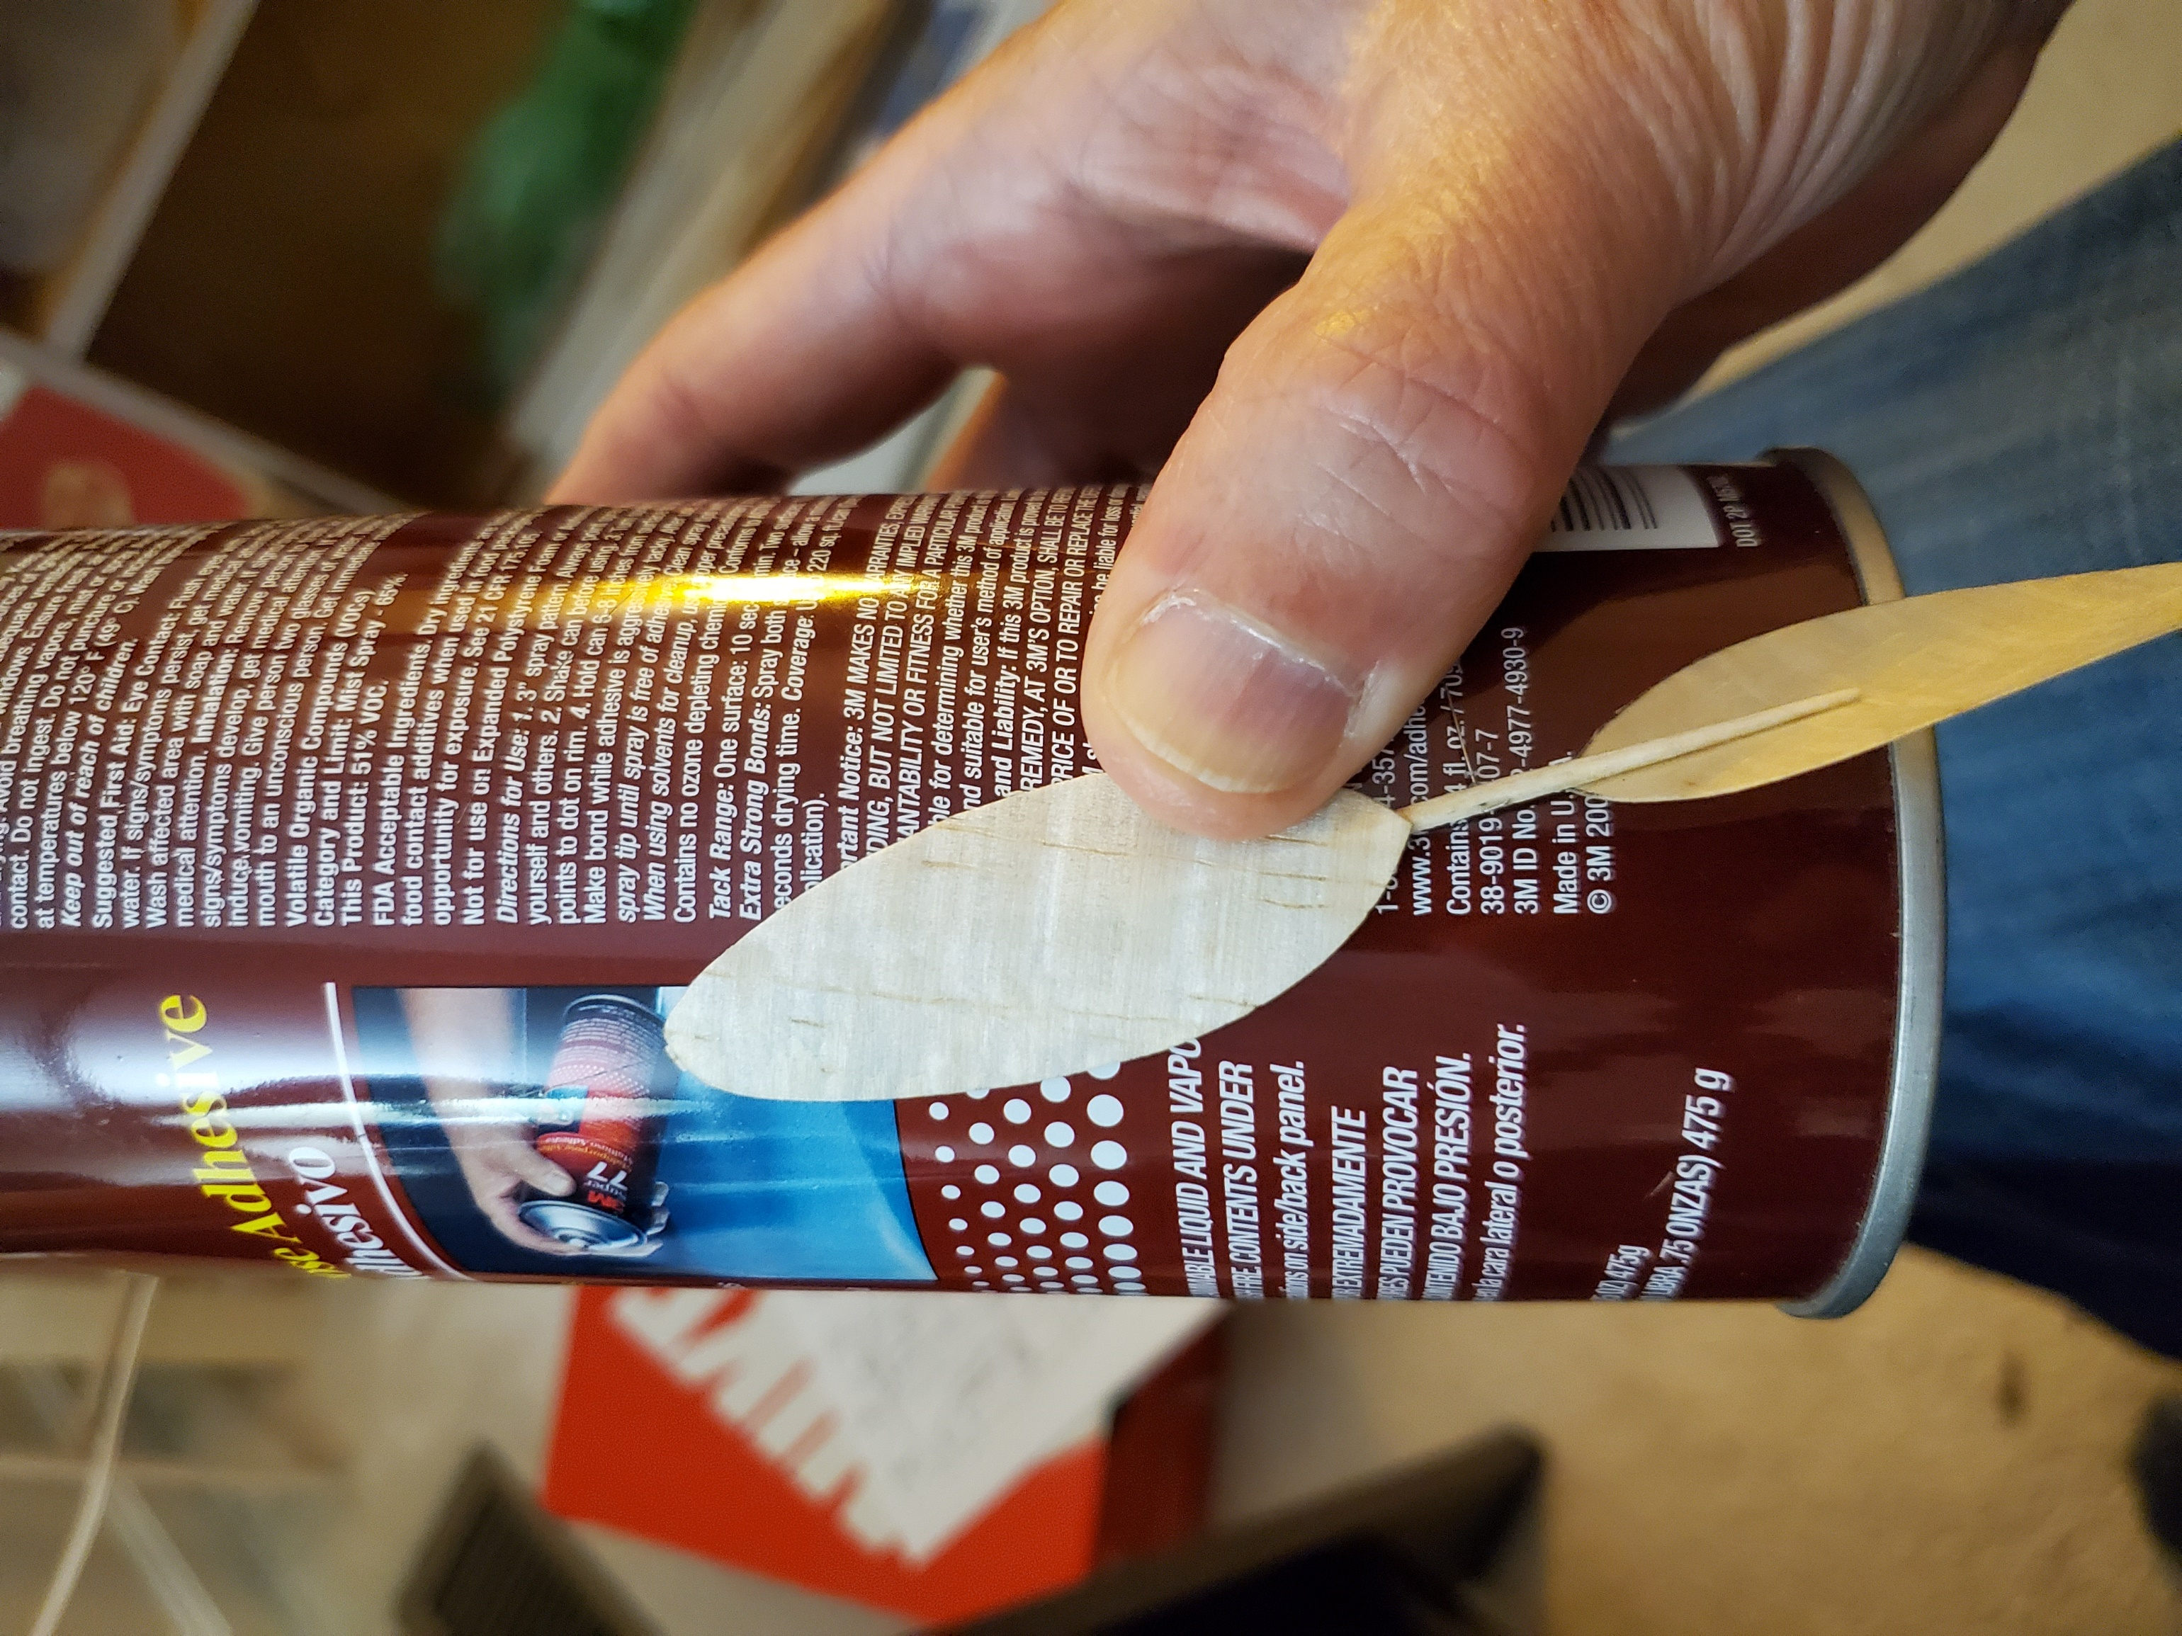

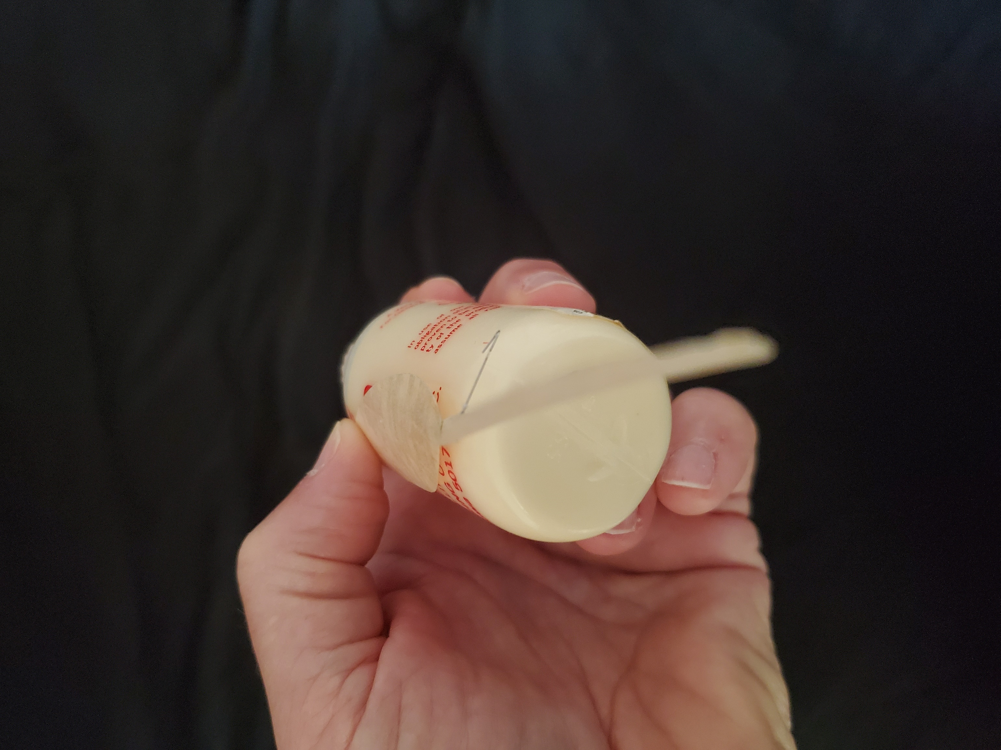

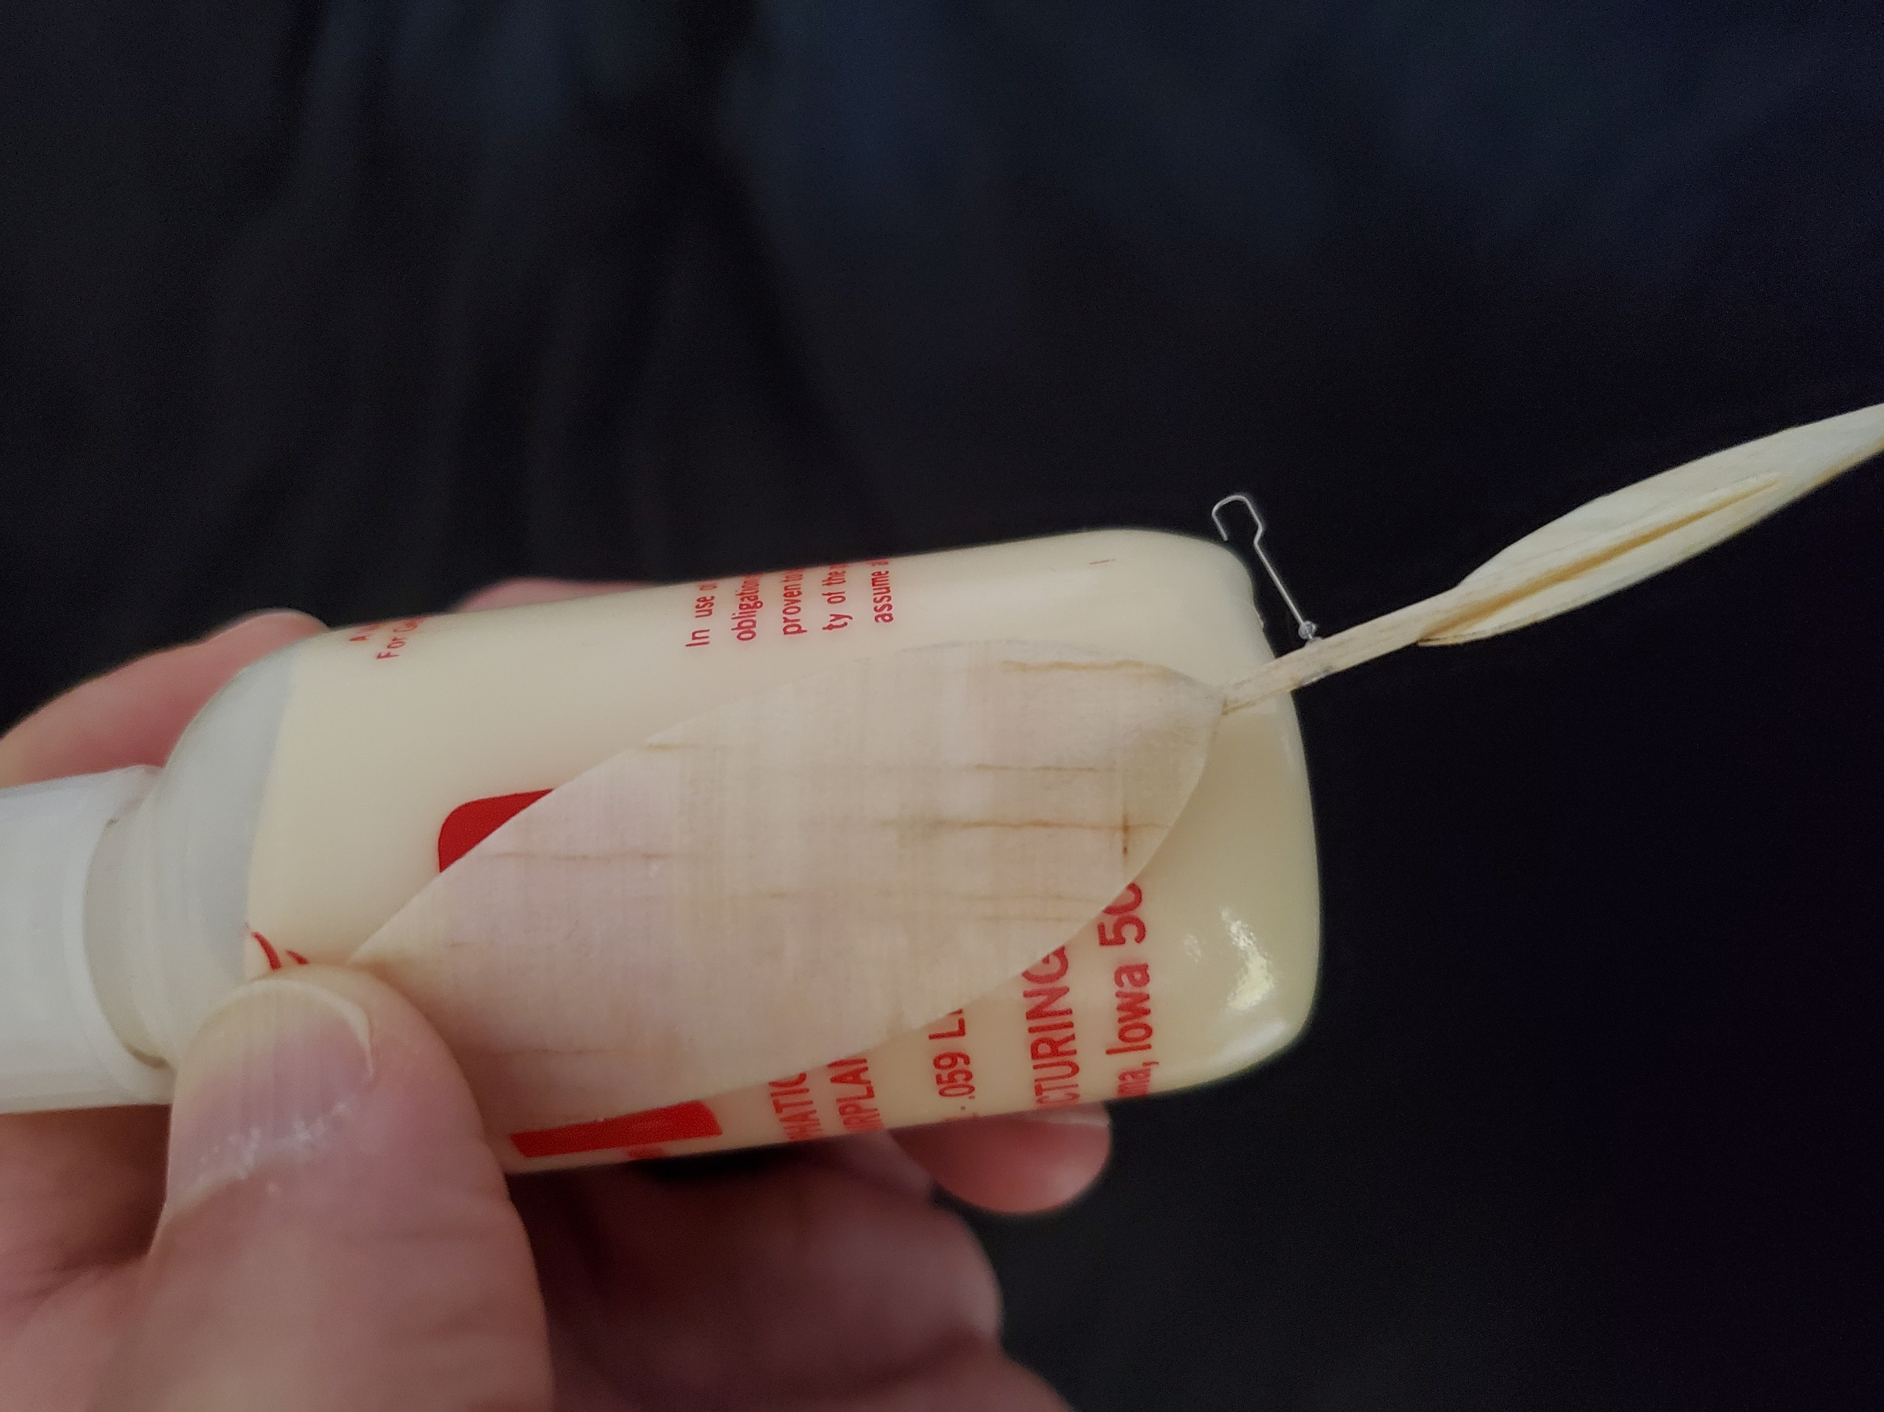

- Note the spar line I added at the bottom for the new Scraps flaring prop, in addition to the previous non-flaring spar line in the center.

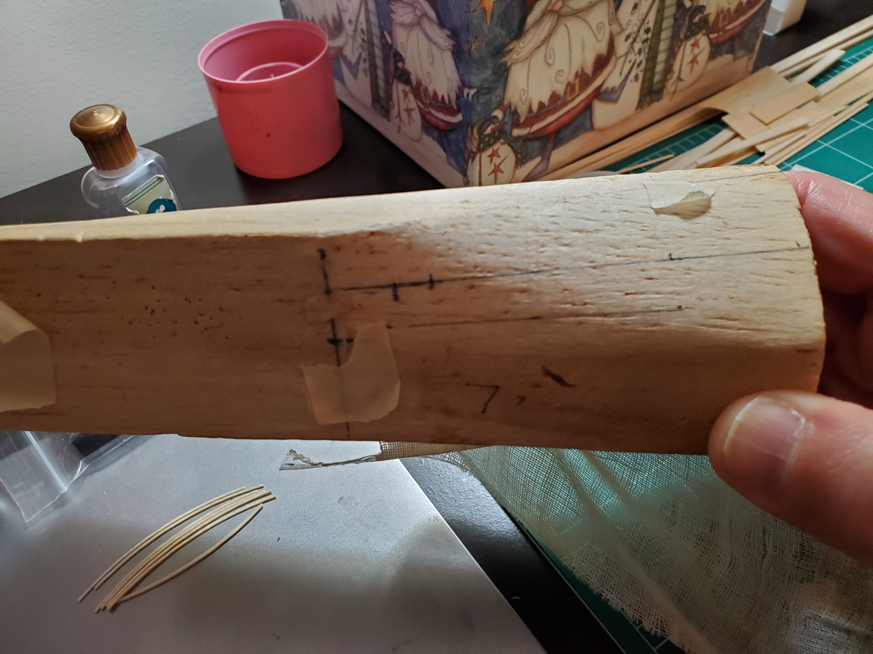

- Soak the blade (you don’t need to soak it for very long since it is so thin – I just dunk it, squeegee it off with my fingers, and put it right on the block), line it up with the spar line, wrap it with some gauze, tape it down, and let it dry overnight

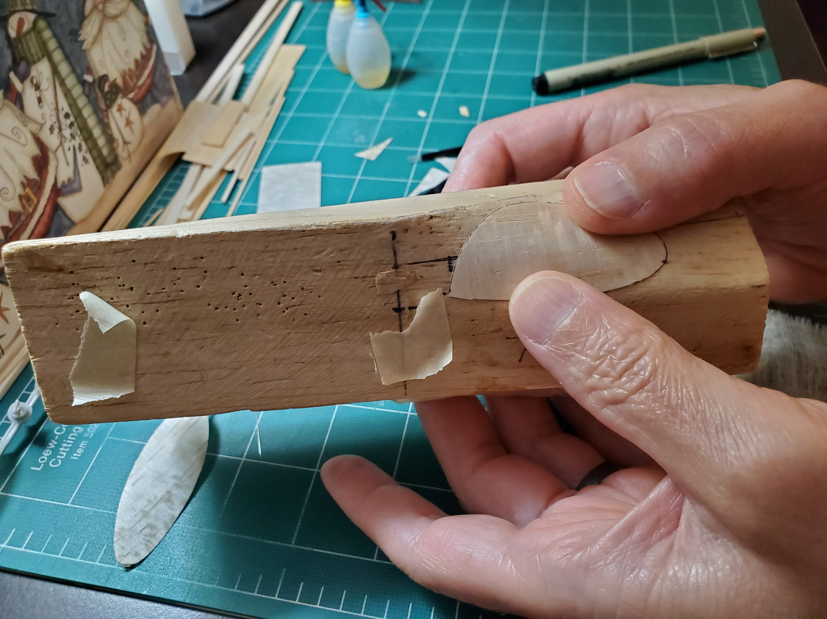

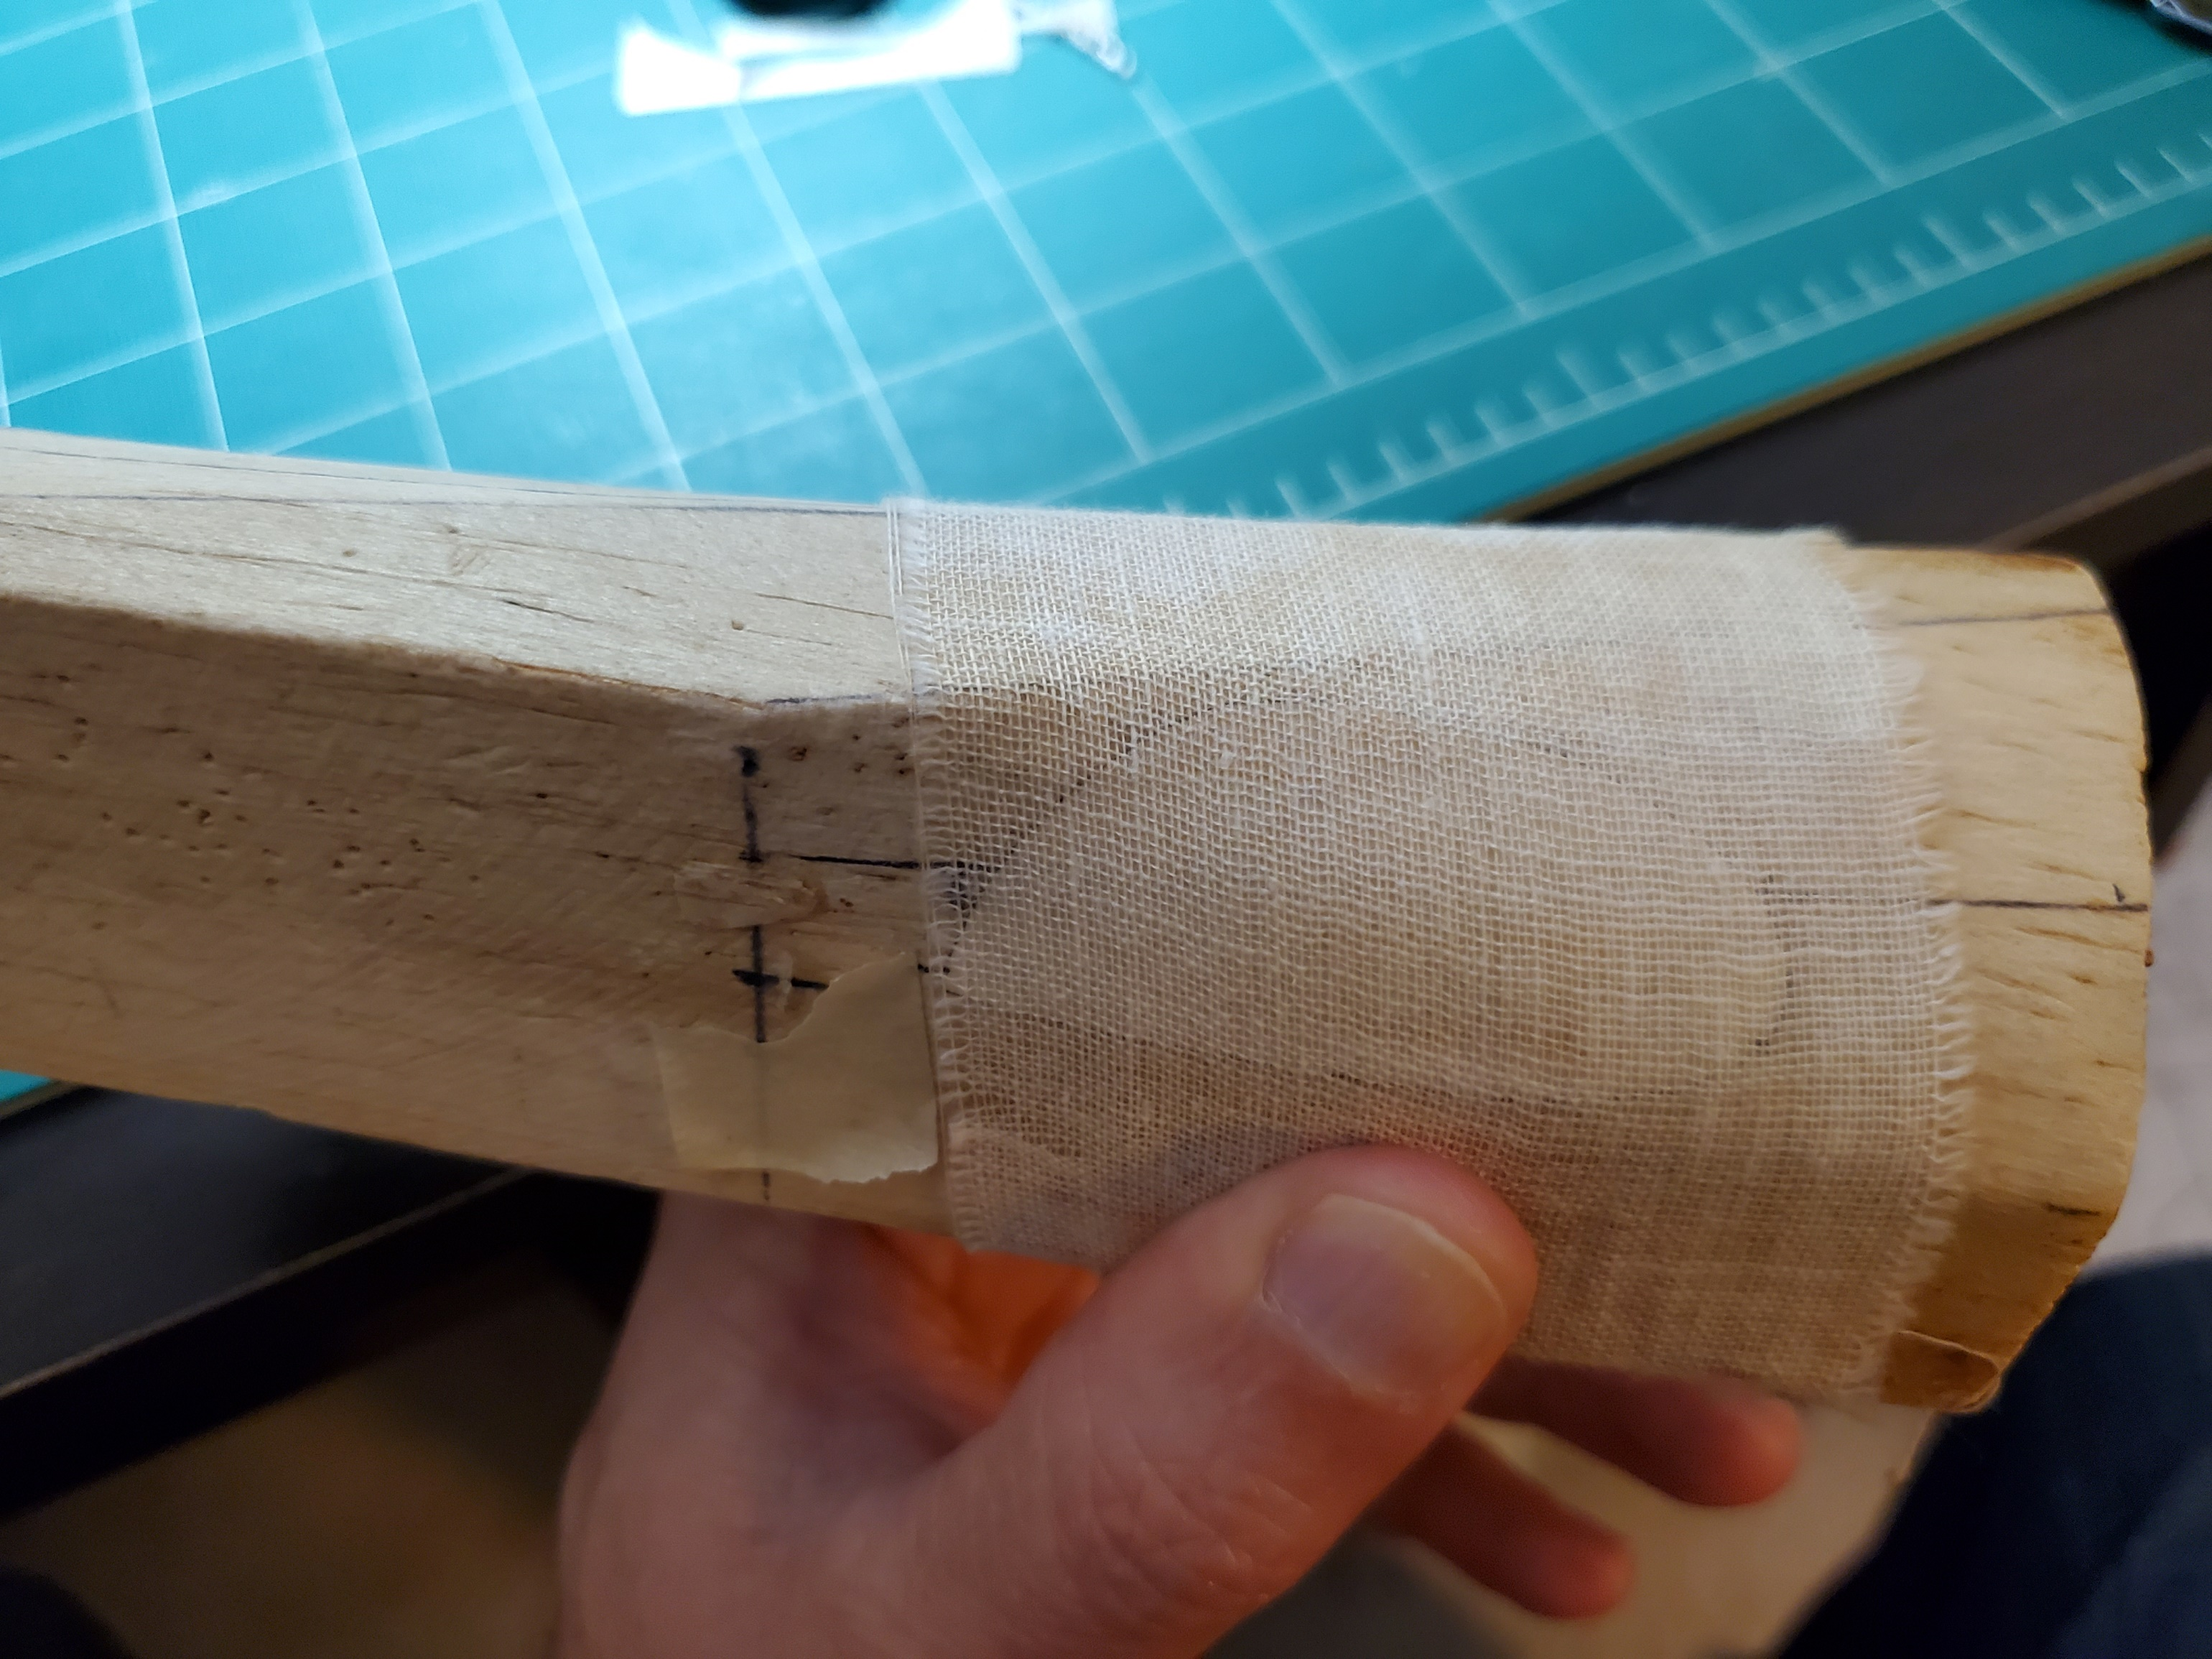

- In the meantime, form the prop shaft and spar. For the shaft, I used some non-spring tempered stainless .010” wire that was good for absolutely nothing else. Worked find for the low loads on Scraps, though. Here’s a simple hook shape. A reverse S hook is better, though – it does a better job of keeping the O ring from climbing up and locking the prop

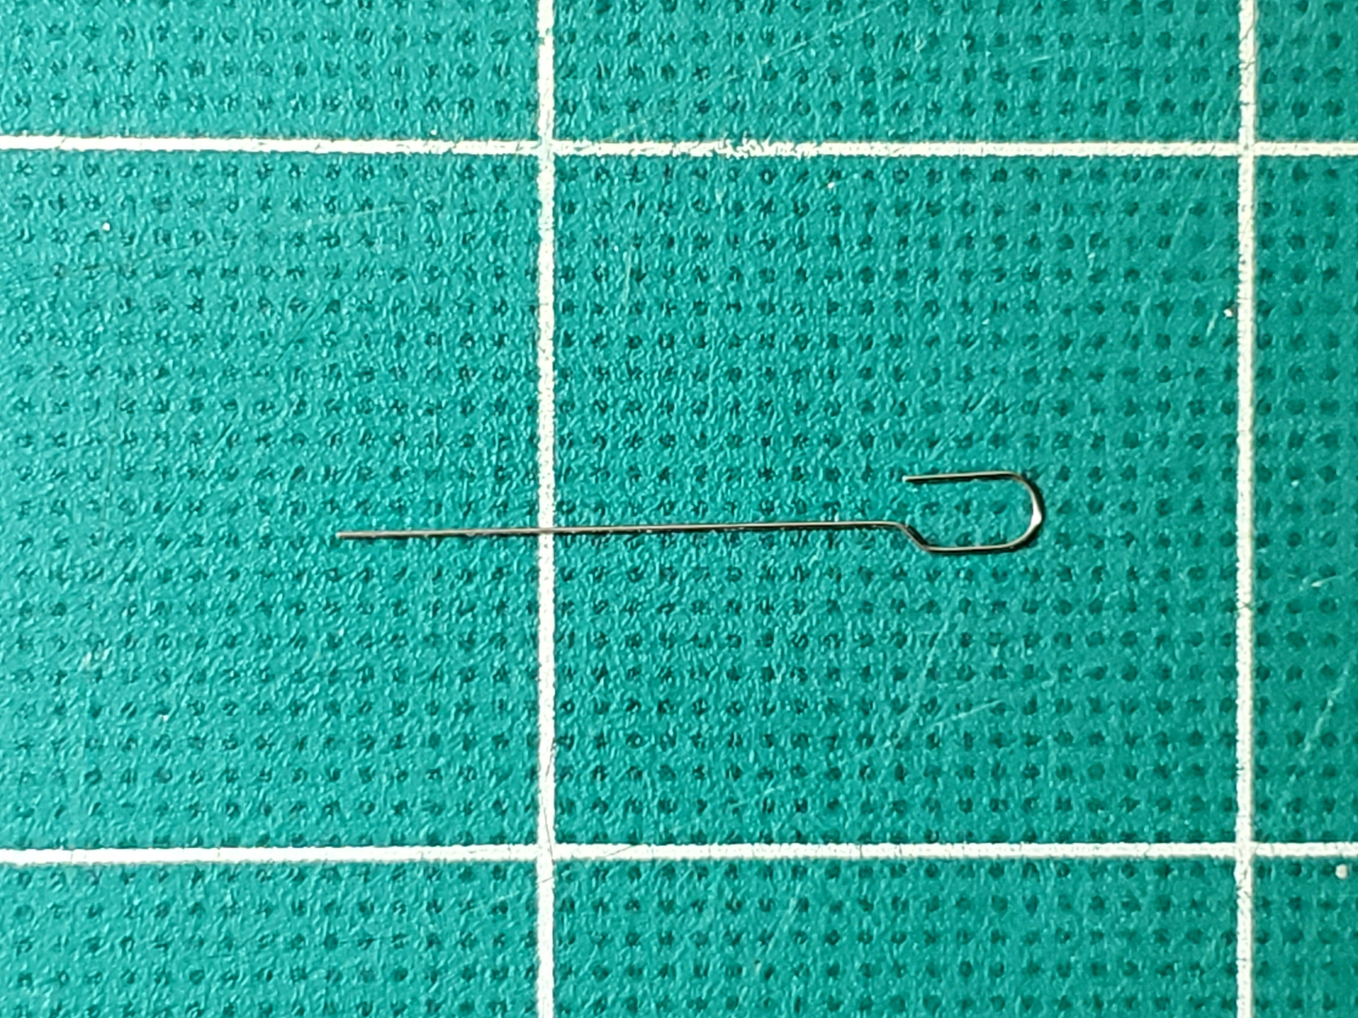

- For the spar, you can use 1/16” balsa tapered and rounded (I used this on my first prop), or something similar to .022” x .025” basswood tapered toward the ends (I put this on my second prop in an attempt to get more flare. I don’t think it worked much, though). Cutting the basswood was a challenge. I had to do several light passes with the stripper rather than trying to cut all the way through on the first pass.

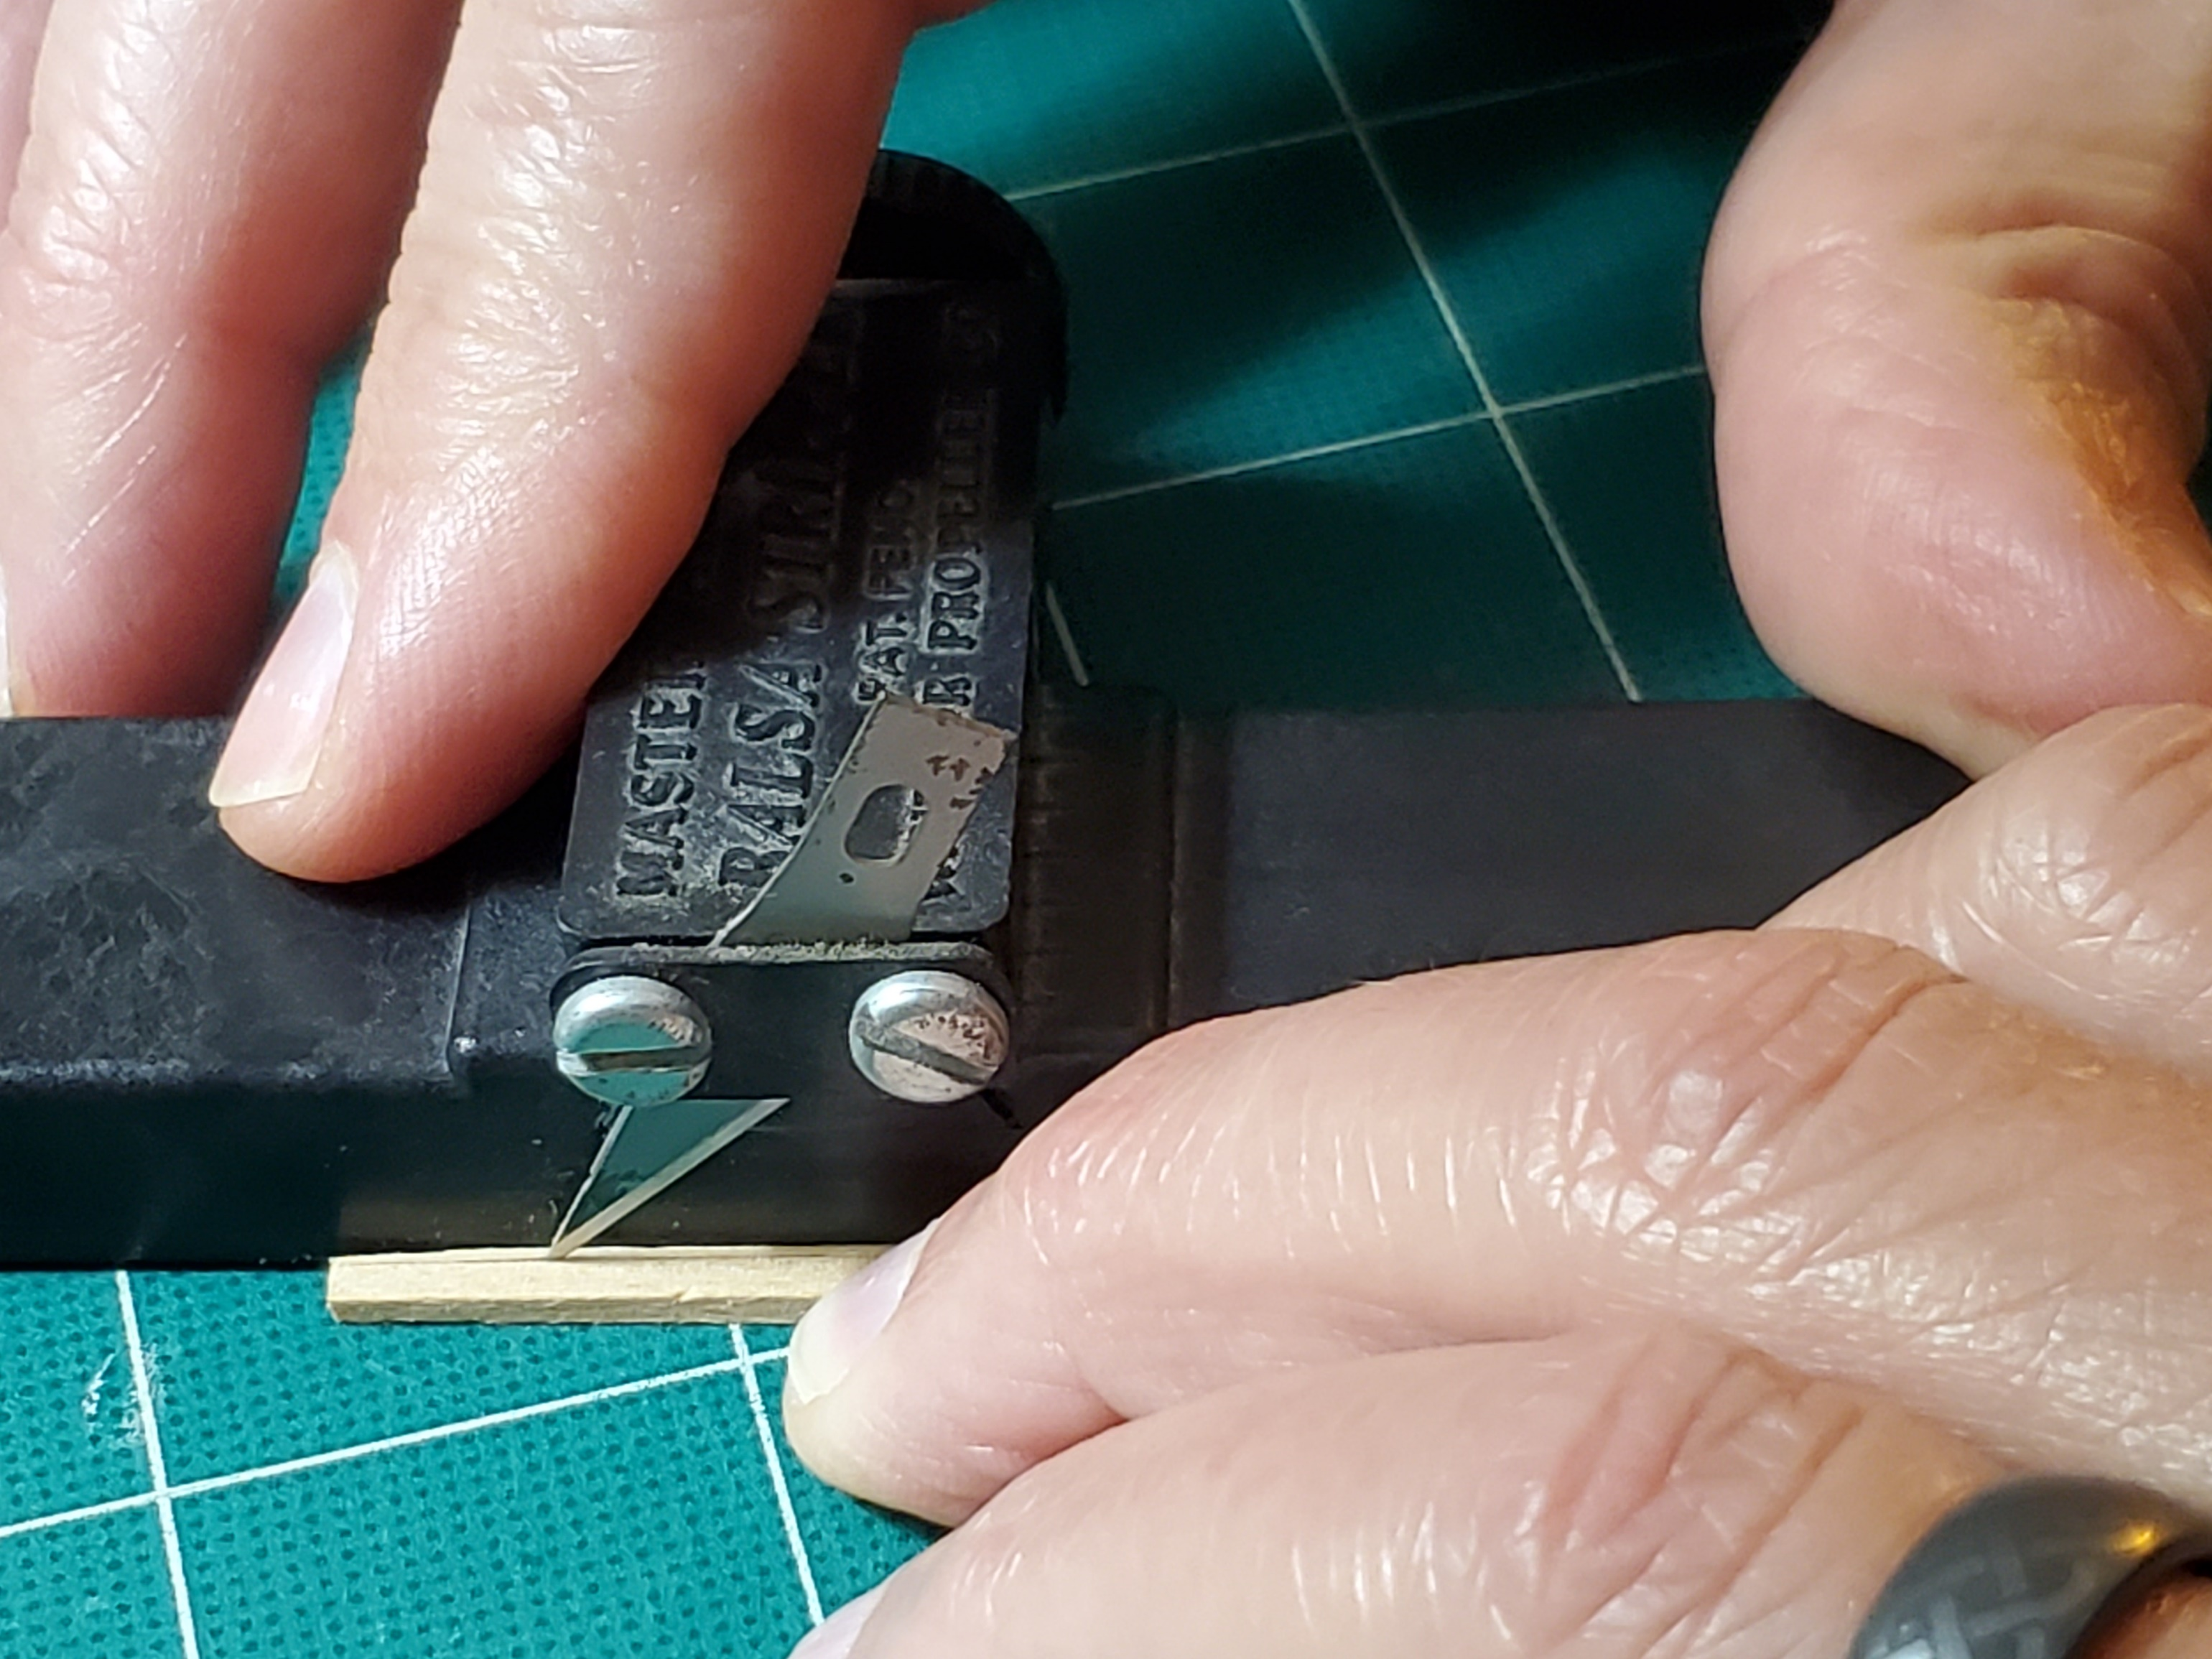

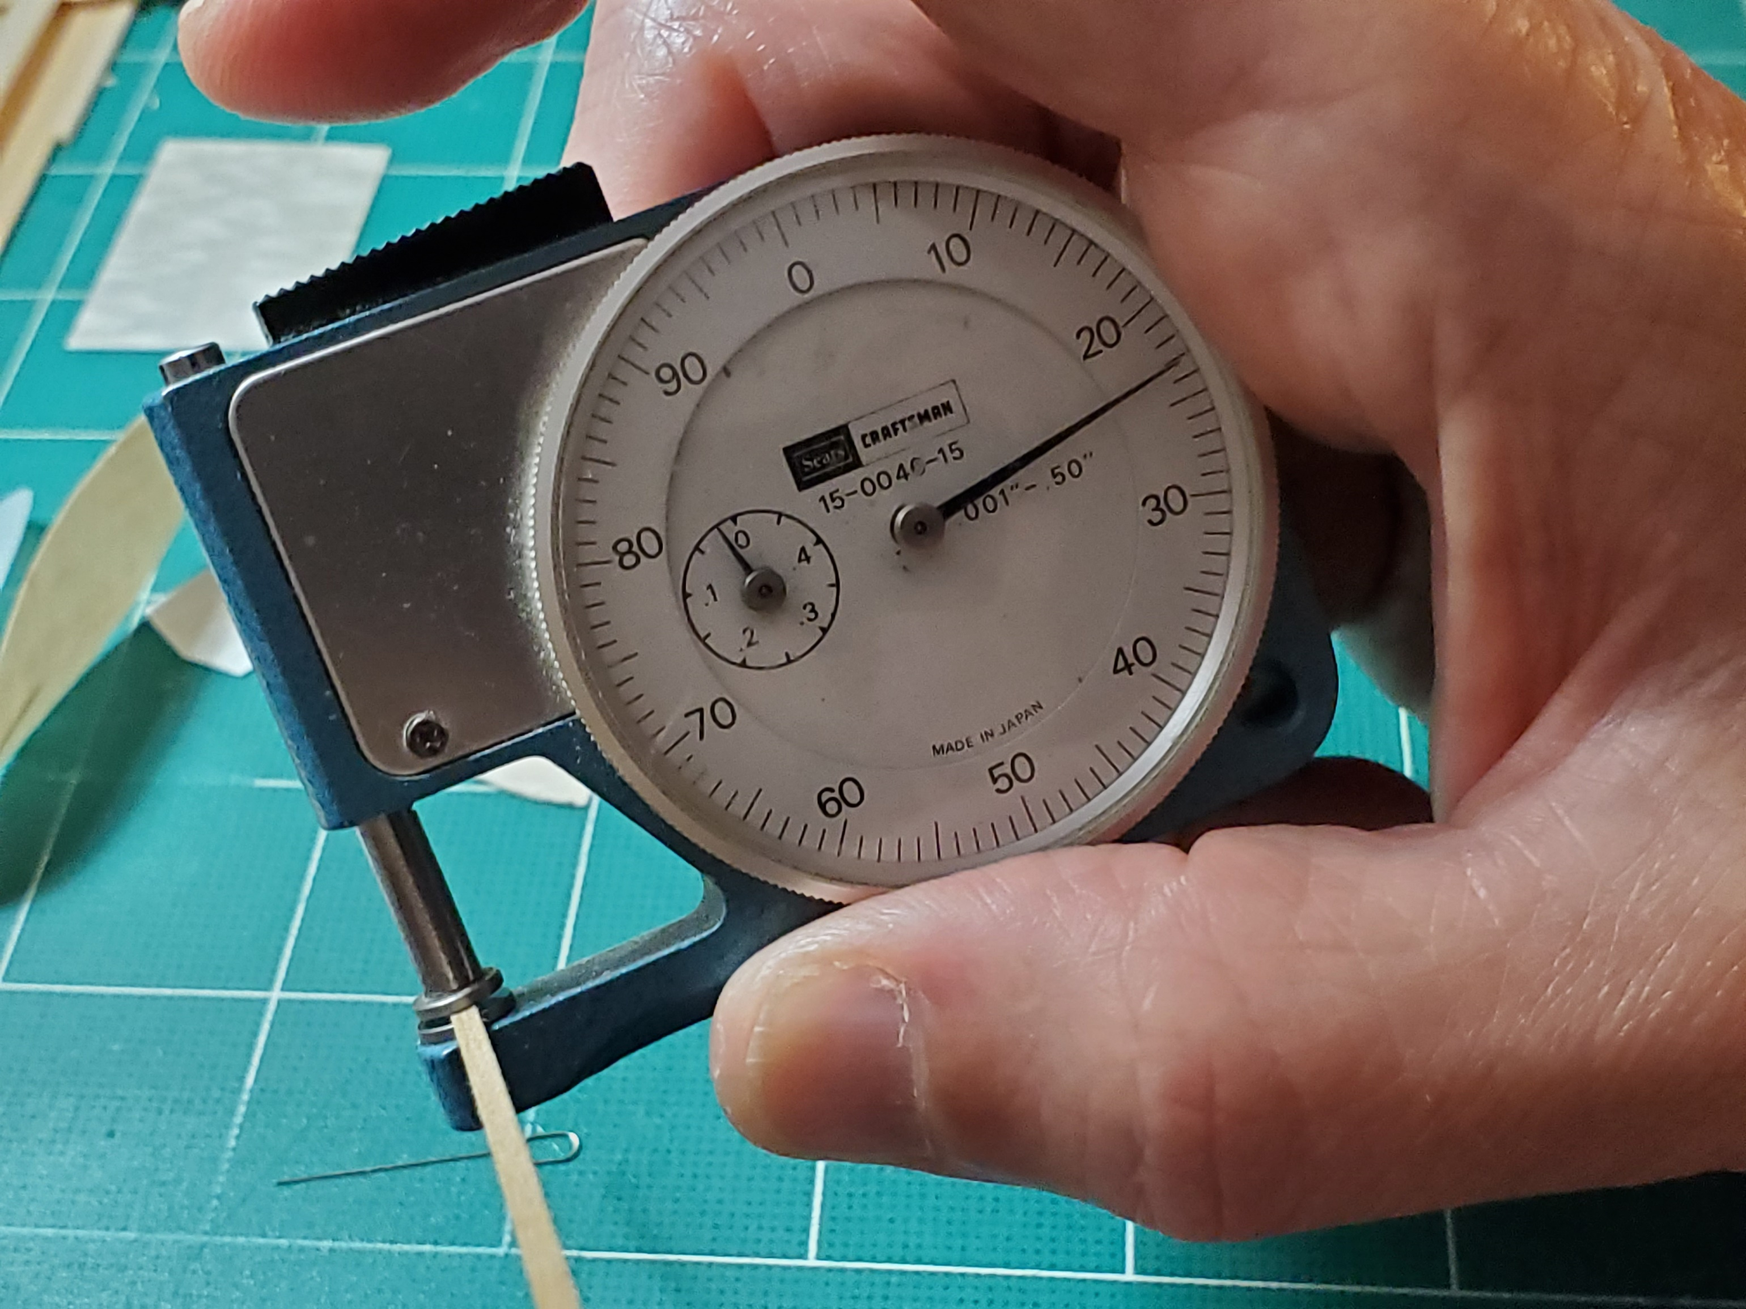

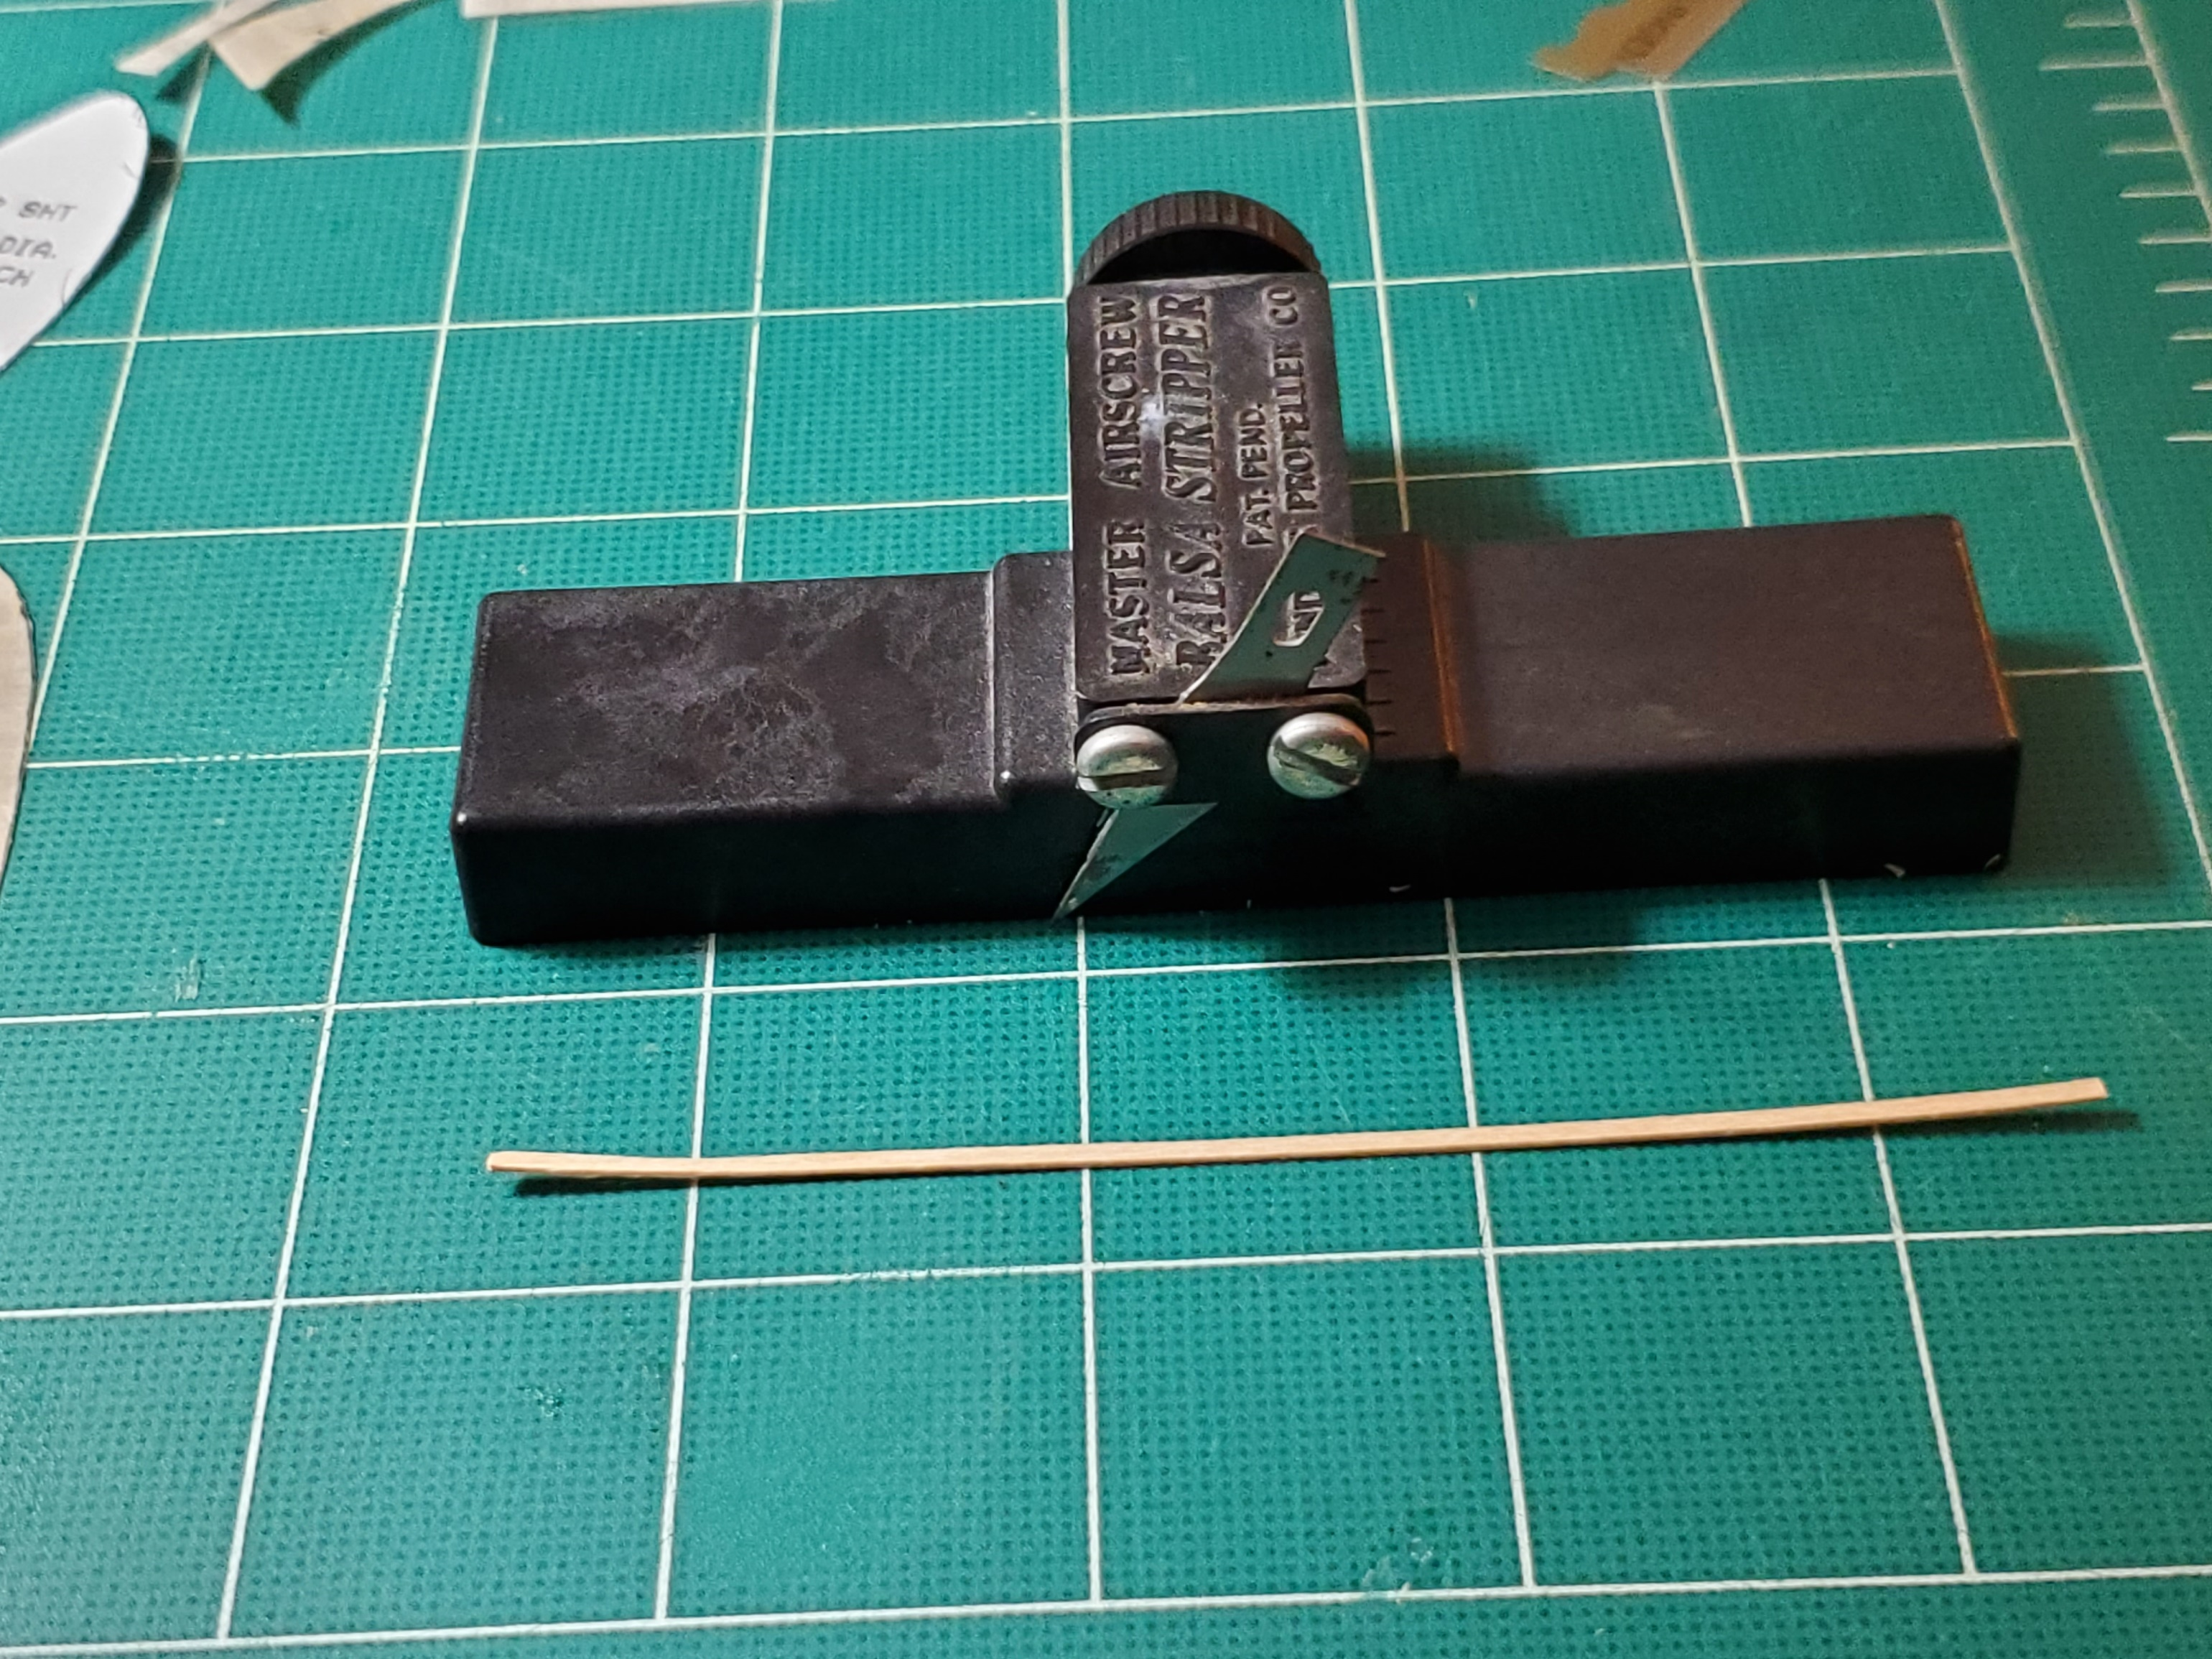

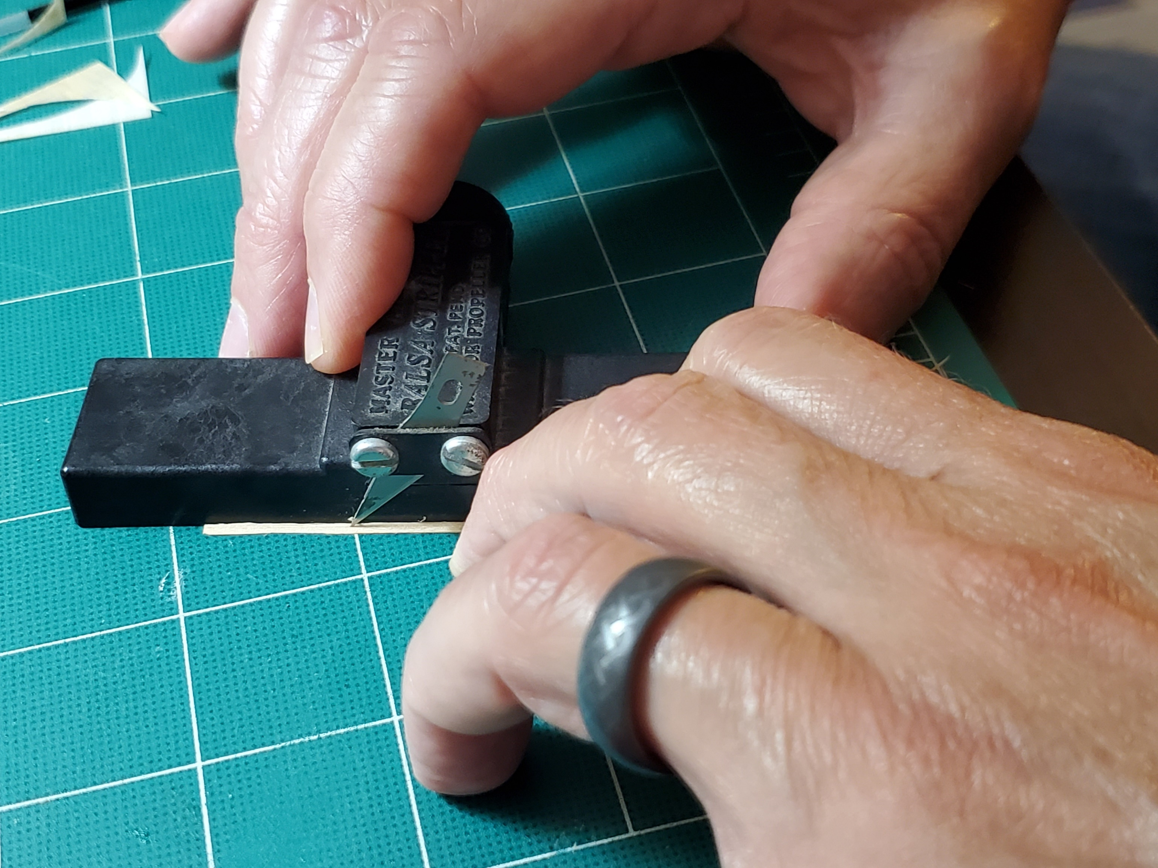

- The strip came out pretty curved, so I ran it though my fingers, bending as it went, until it was straight

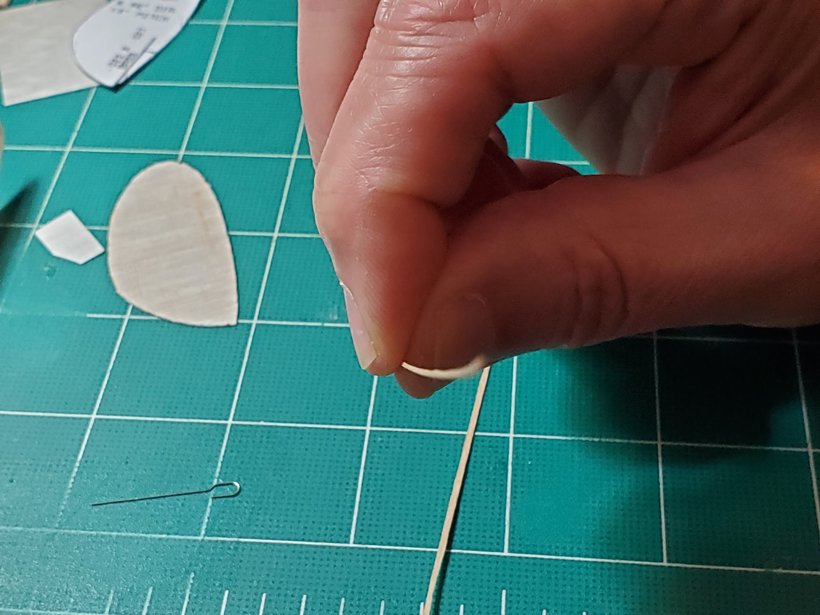

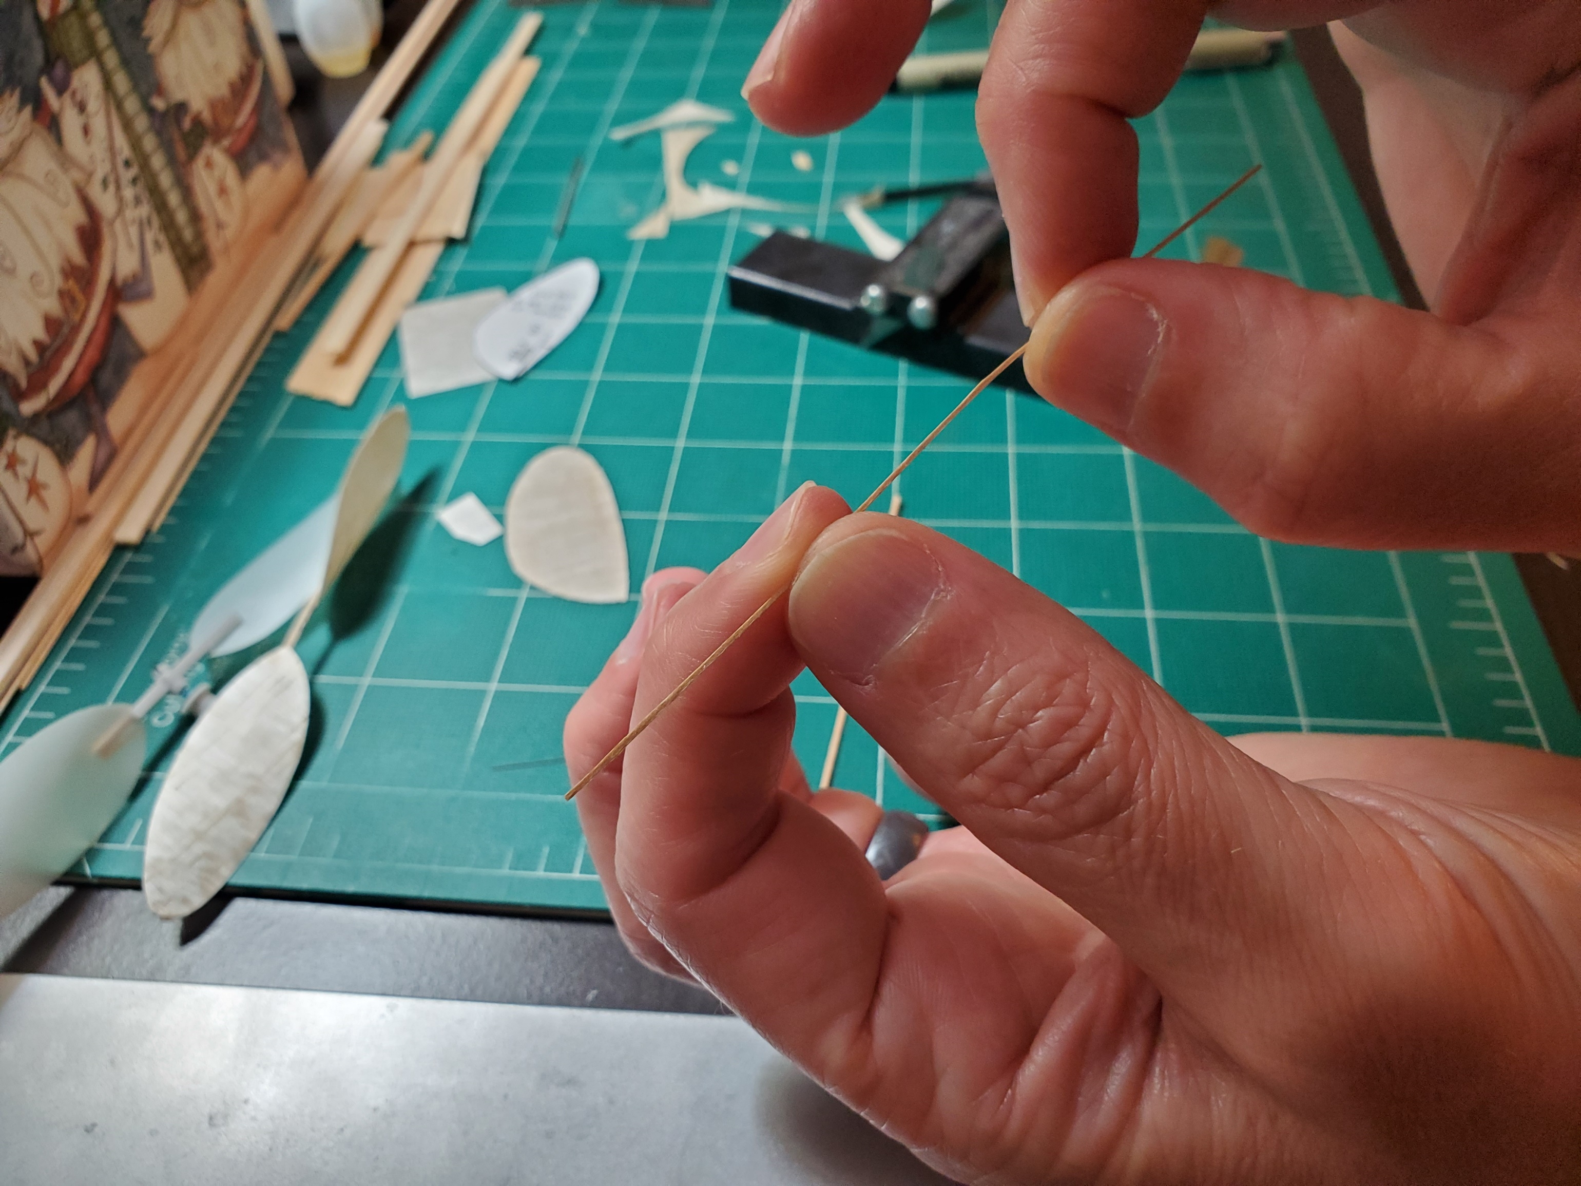

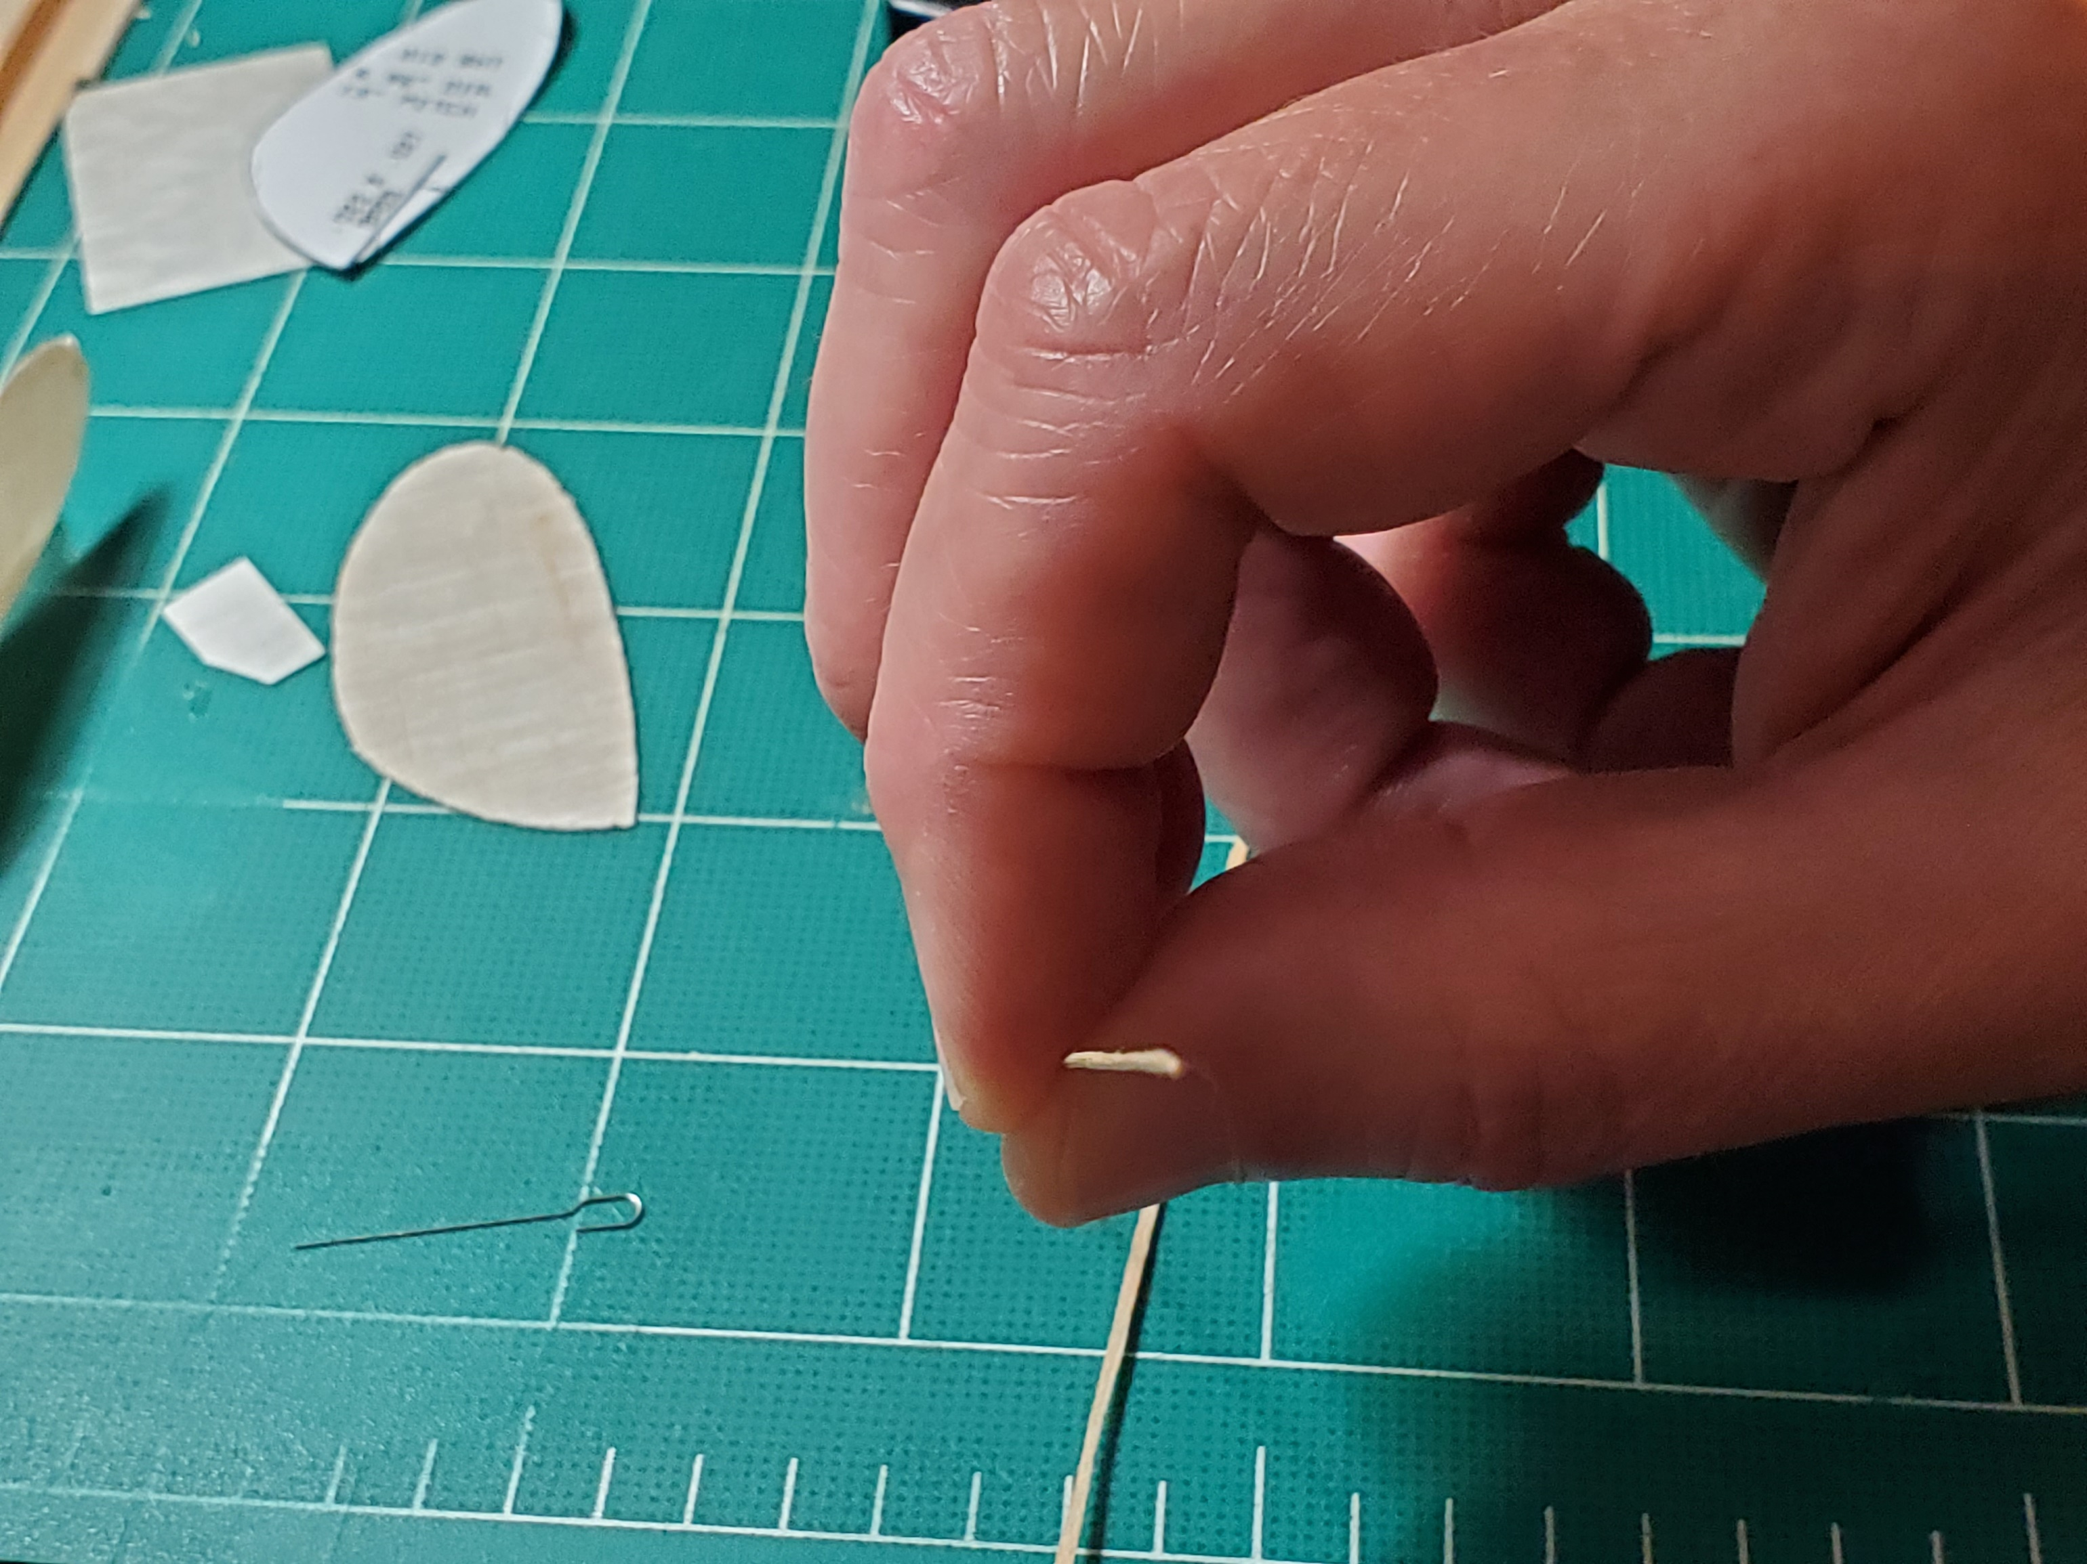

- Measure the length of prop shaft require to fit in your prop hanger. If you are using a balsa prop spar, drill a hole in it, insert the prop shaft, put two 90 degree bends in the end, and glue it down. If you are using a basswood prop spar, put the two 90 degree bends in the prop shaft first, glue it to the side of the prop spar, and glue an extra “retainer plate” over the shaft. Here is the shaft bent and glued in place, with two Teflon washers installed

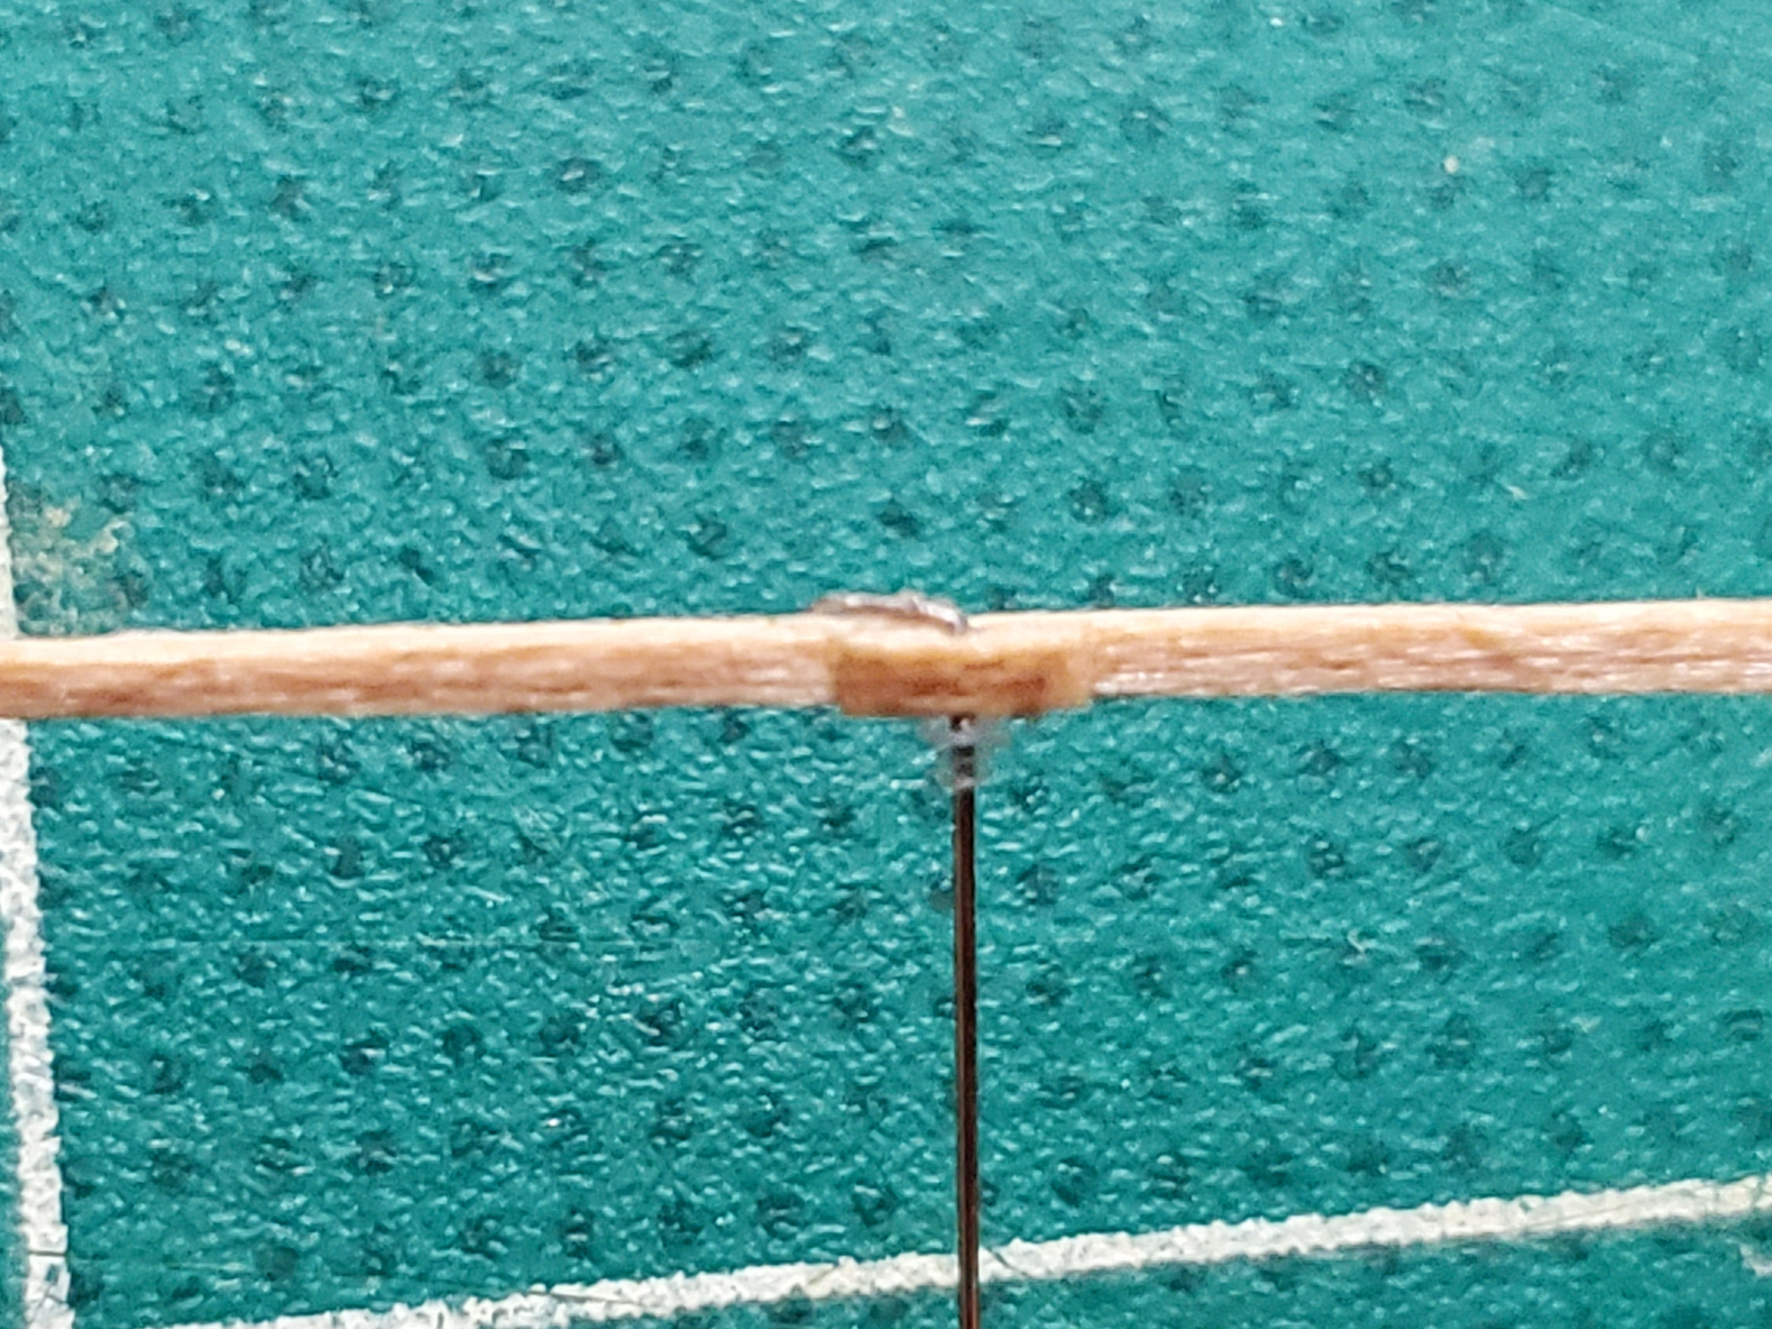

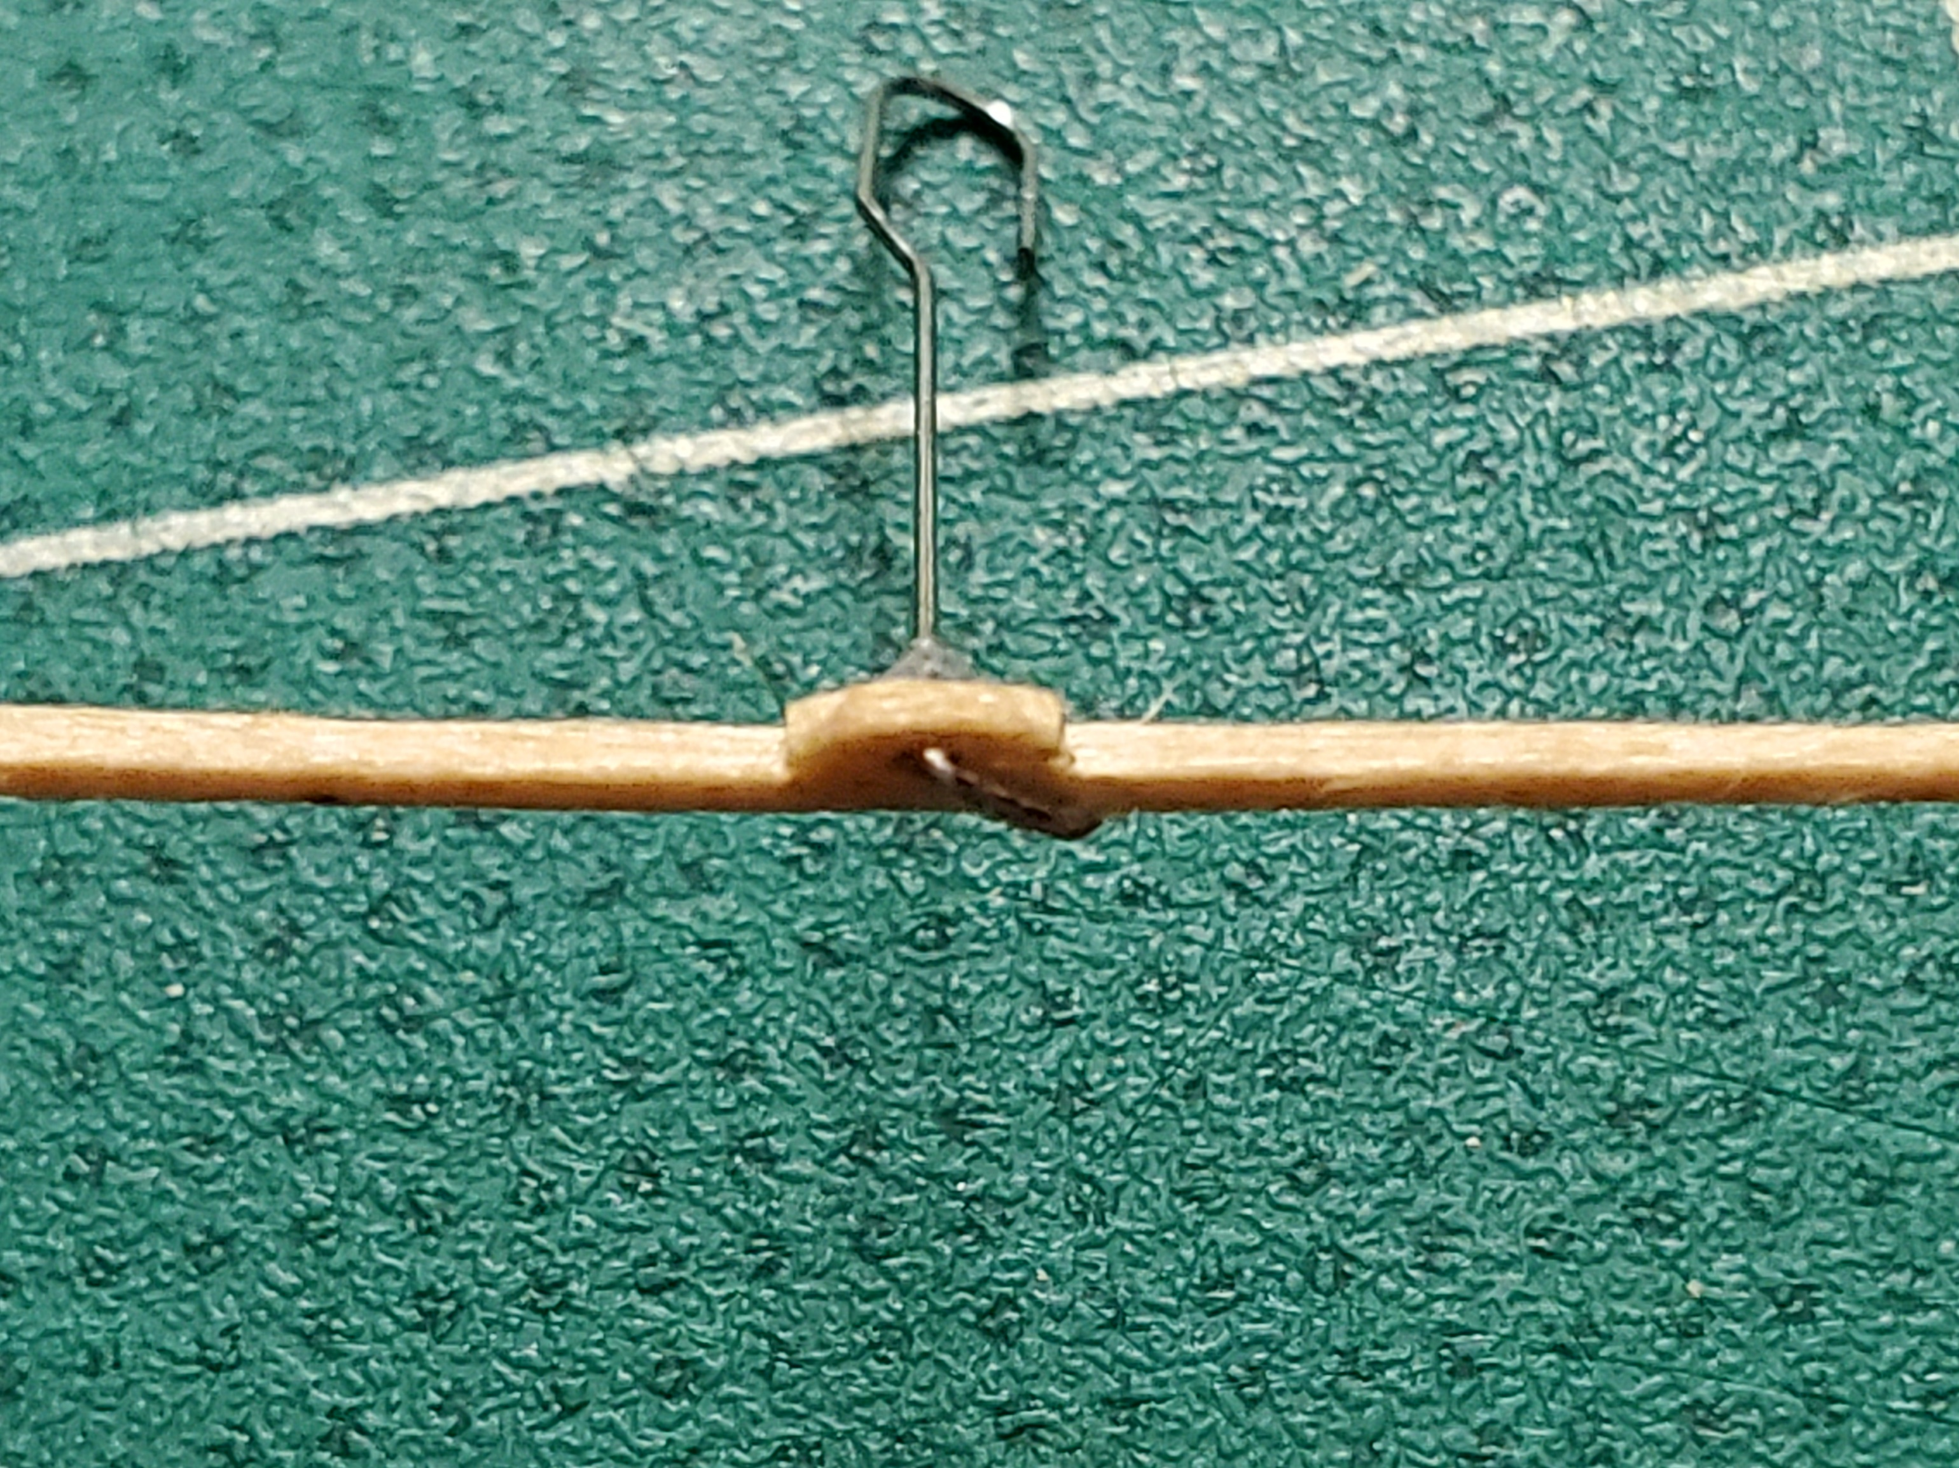

- Gluing the prop blades onto the spar can be a bit tricky. I tape the shaft/spar down on the prop block, line it up with the spar line, put some dots of glue on the spar, carefully line up the prop blade, and lightly tape it down until it dries. For this prop, I wanted a bit less pitch, so I propped up the front of the shaft with a scrap of wood when I tapped it down

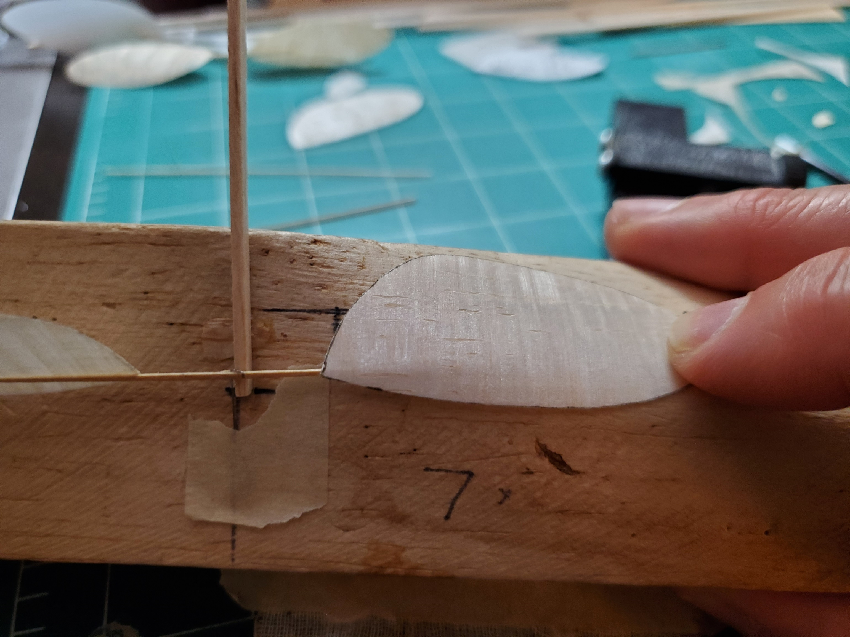

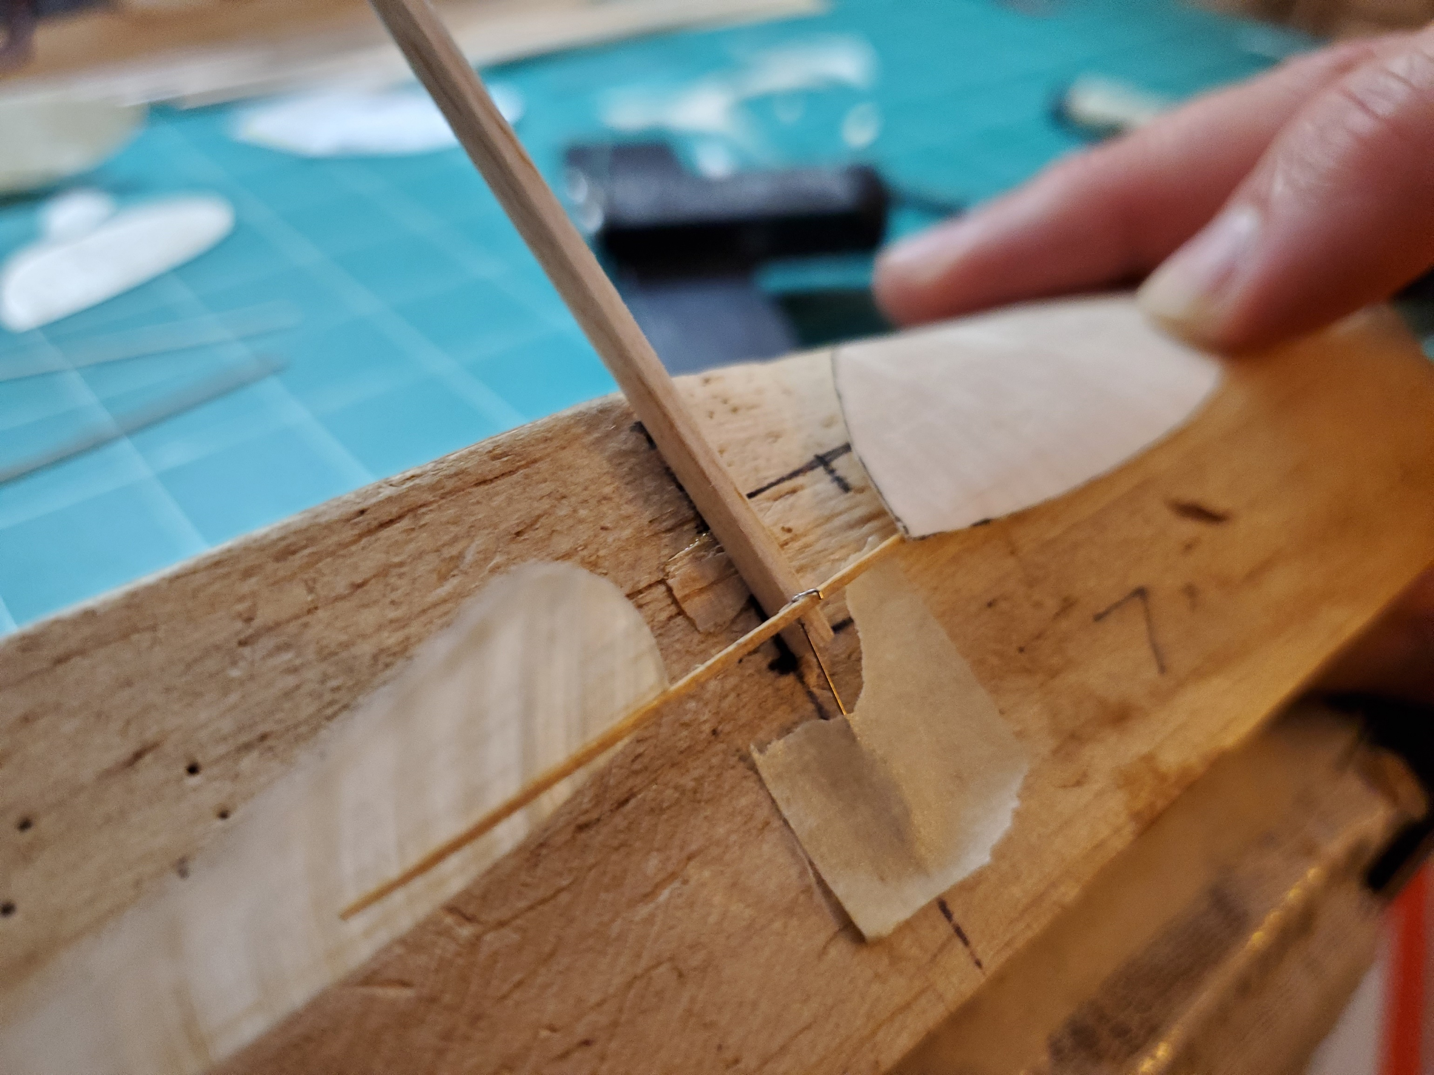

- You can measure the prop pitch with a gauge, if you have one. If you don’t, a nice method is to hold one blade tip flat on the table, and adjust the pitch until the other blade tip is about 60 degrees (which is 30 degrees for each tip, which is a pitch to diameter ratio of about 1.8)

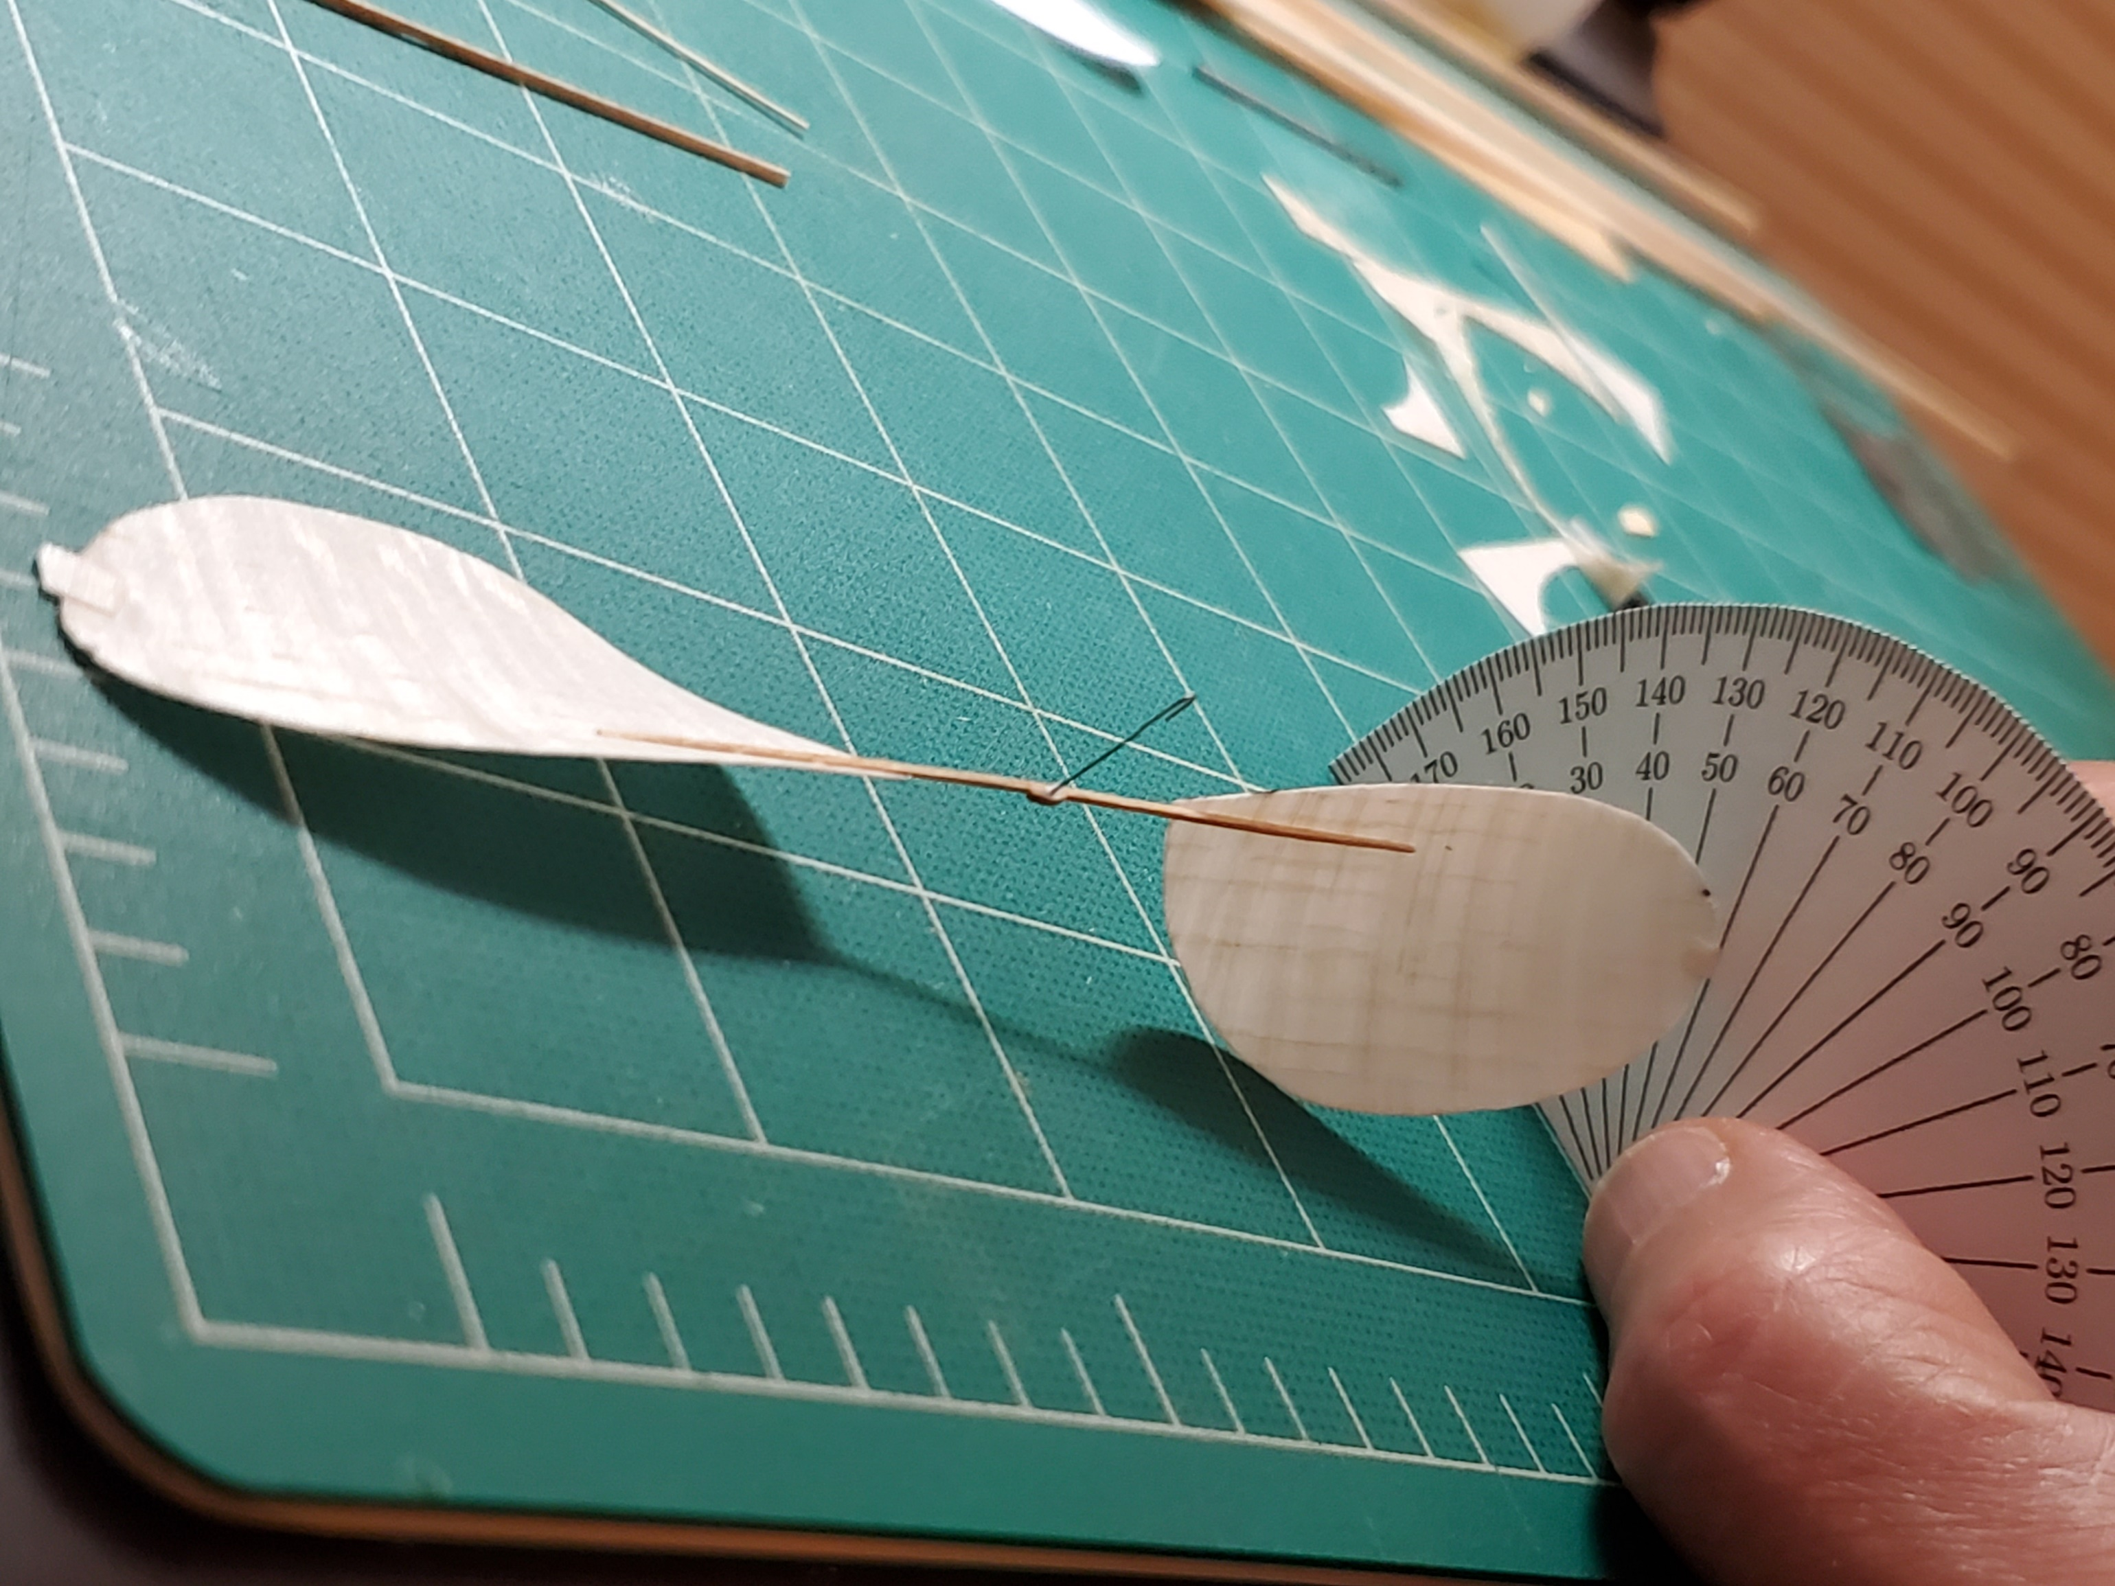

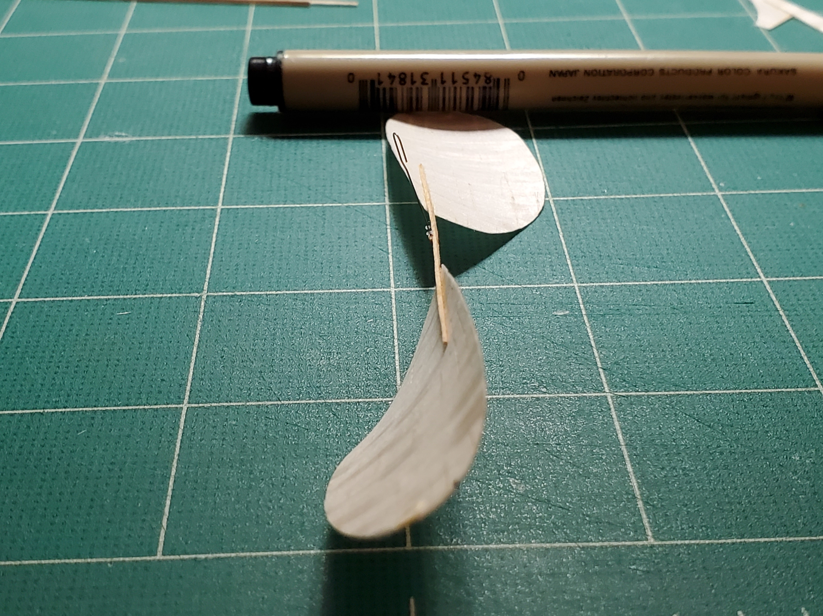

- Put the prop on your model and go fly! It took about three times longer to write this all up than it took to make the actual prop 😊

